RANGIORA HIGH SCHOOL

STRATEGIC PLAN & ANALYSIS OF VARIANCE
2024 (for the 2023 school year)

Vision and Values Page 2
Part One: Overall Strategic Direction Page 3
Part Two: Analysis of 2023
1. Key Strategic Data
- Achievement Page 5
  - Pass Rates
  - Endorsements
  - Literacy and Numeracy
  - Māori Pass Rates
- Attendance Page 5
  - All
  - Māori
  - Gender
  - Non-attendance
- Leavers Data Page 7
  - All Leavers
  - Māori
- Overview Page 8
2. Key Performance Indicators
- Analysis of variance Page 9
- Annual Target Review and 2024 Recommendations Page 10
Part Three: Overall Strategic Review Page 11
Part Four: 2024 Targets and Goals Page 13
Part Five: Additional Compliance Reporting
- Treaty of Waitangi Page 15
- EEO Page 23
Part Six: 2024 Strategic Plan Page 24
Part Seven: Appendix
- Report on annual target progression
a. Learning Page 25
b. Curriculum Page 28
c. Wellbeing Page 30
d. Culture Page 33
- EEO Policy Page 34

VISION AND VALUES
VISION, LEARNER PROFILE AND VALUES
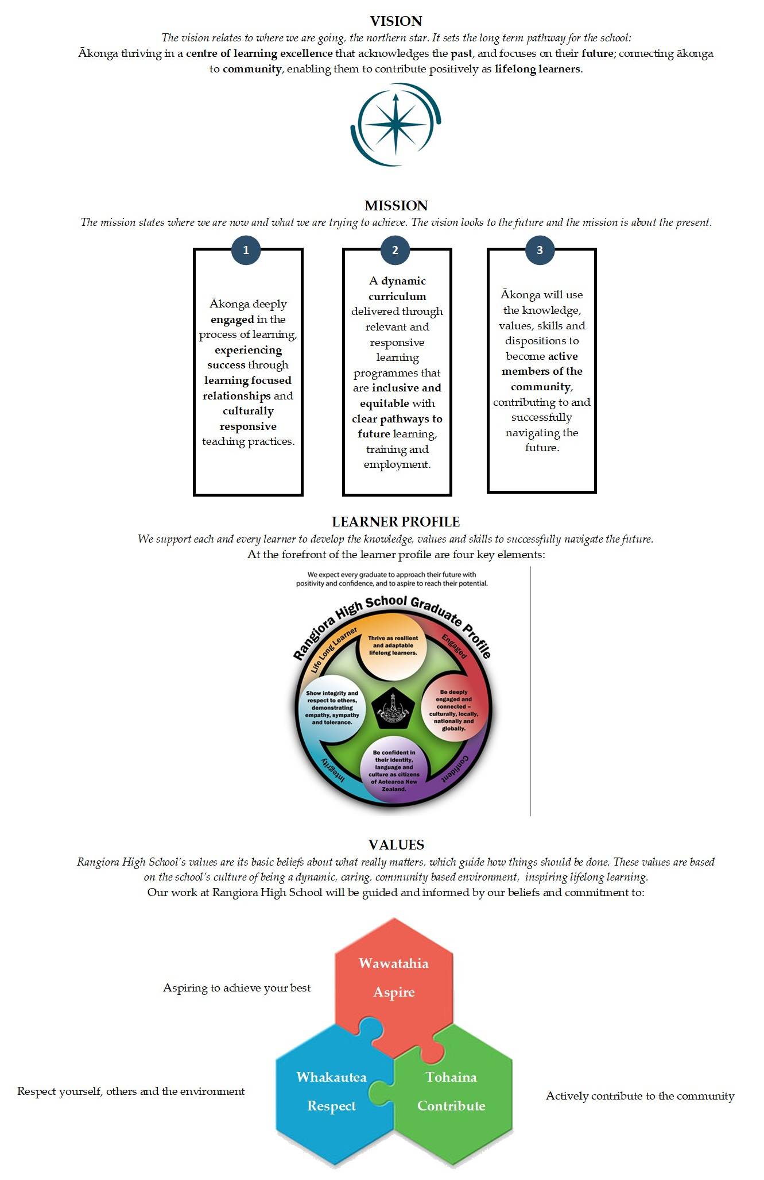

PART ONE:
OVERALL STRATEGIC DIRECTION 2023-2025
Within our 3-year strategic direction the model created has two streams: a CORE FOCUS and a STRAETGIC FOCUS. They combine to create our overall strategic direction.

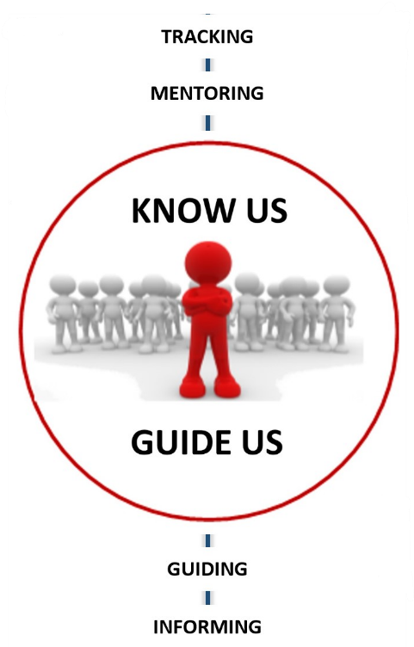
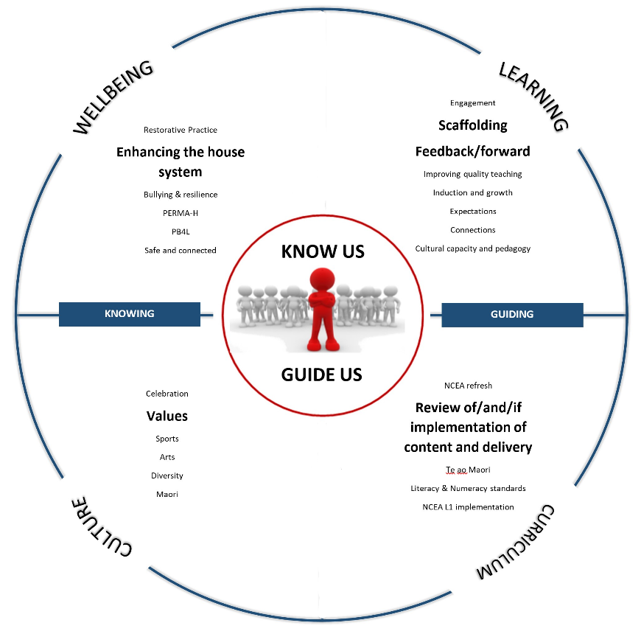
This is the centre pillar; we need to know our students on an individual basis. Step one is to track our students to find those who are at risk or need support. We then place a mentoring programme to sit alongside them. We guide our students through feedback and feedforward. Finally, we inform our students and caregivers through regular reporting that is easy to access and informs of next steps rather than outcomes.
CORE FOCUS
This is the wrap around strategies to ensure the core is maintained.
Knowing our students sits on the left and deals with wellbeing and culture.
Guiding sits on the right and deals with learning and curriculum.
The larger writing (e.g. Values) is the strategic focus. The smaller writing is the Tier One business as usual (e.g. Celebration). There are a number of Tier Two business as usual items not included
STRATEGIC FOCUS

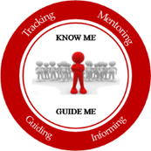

TRACKING
MENTORING
GUIDING
INFORMING

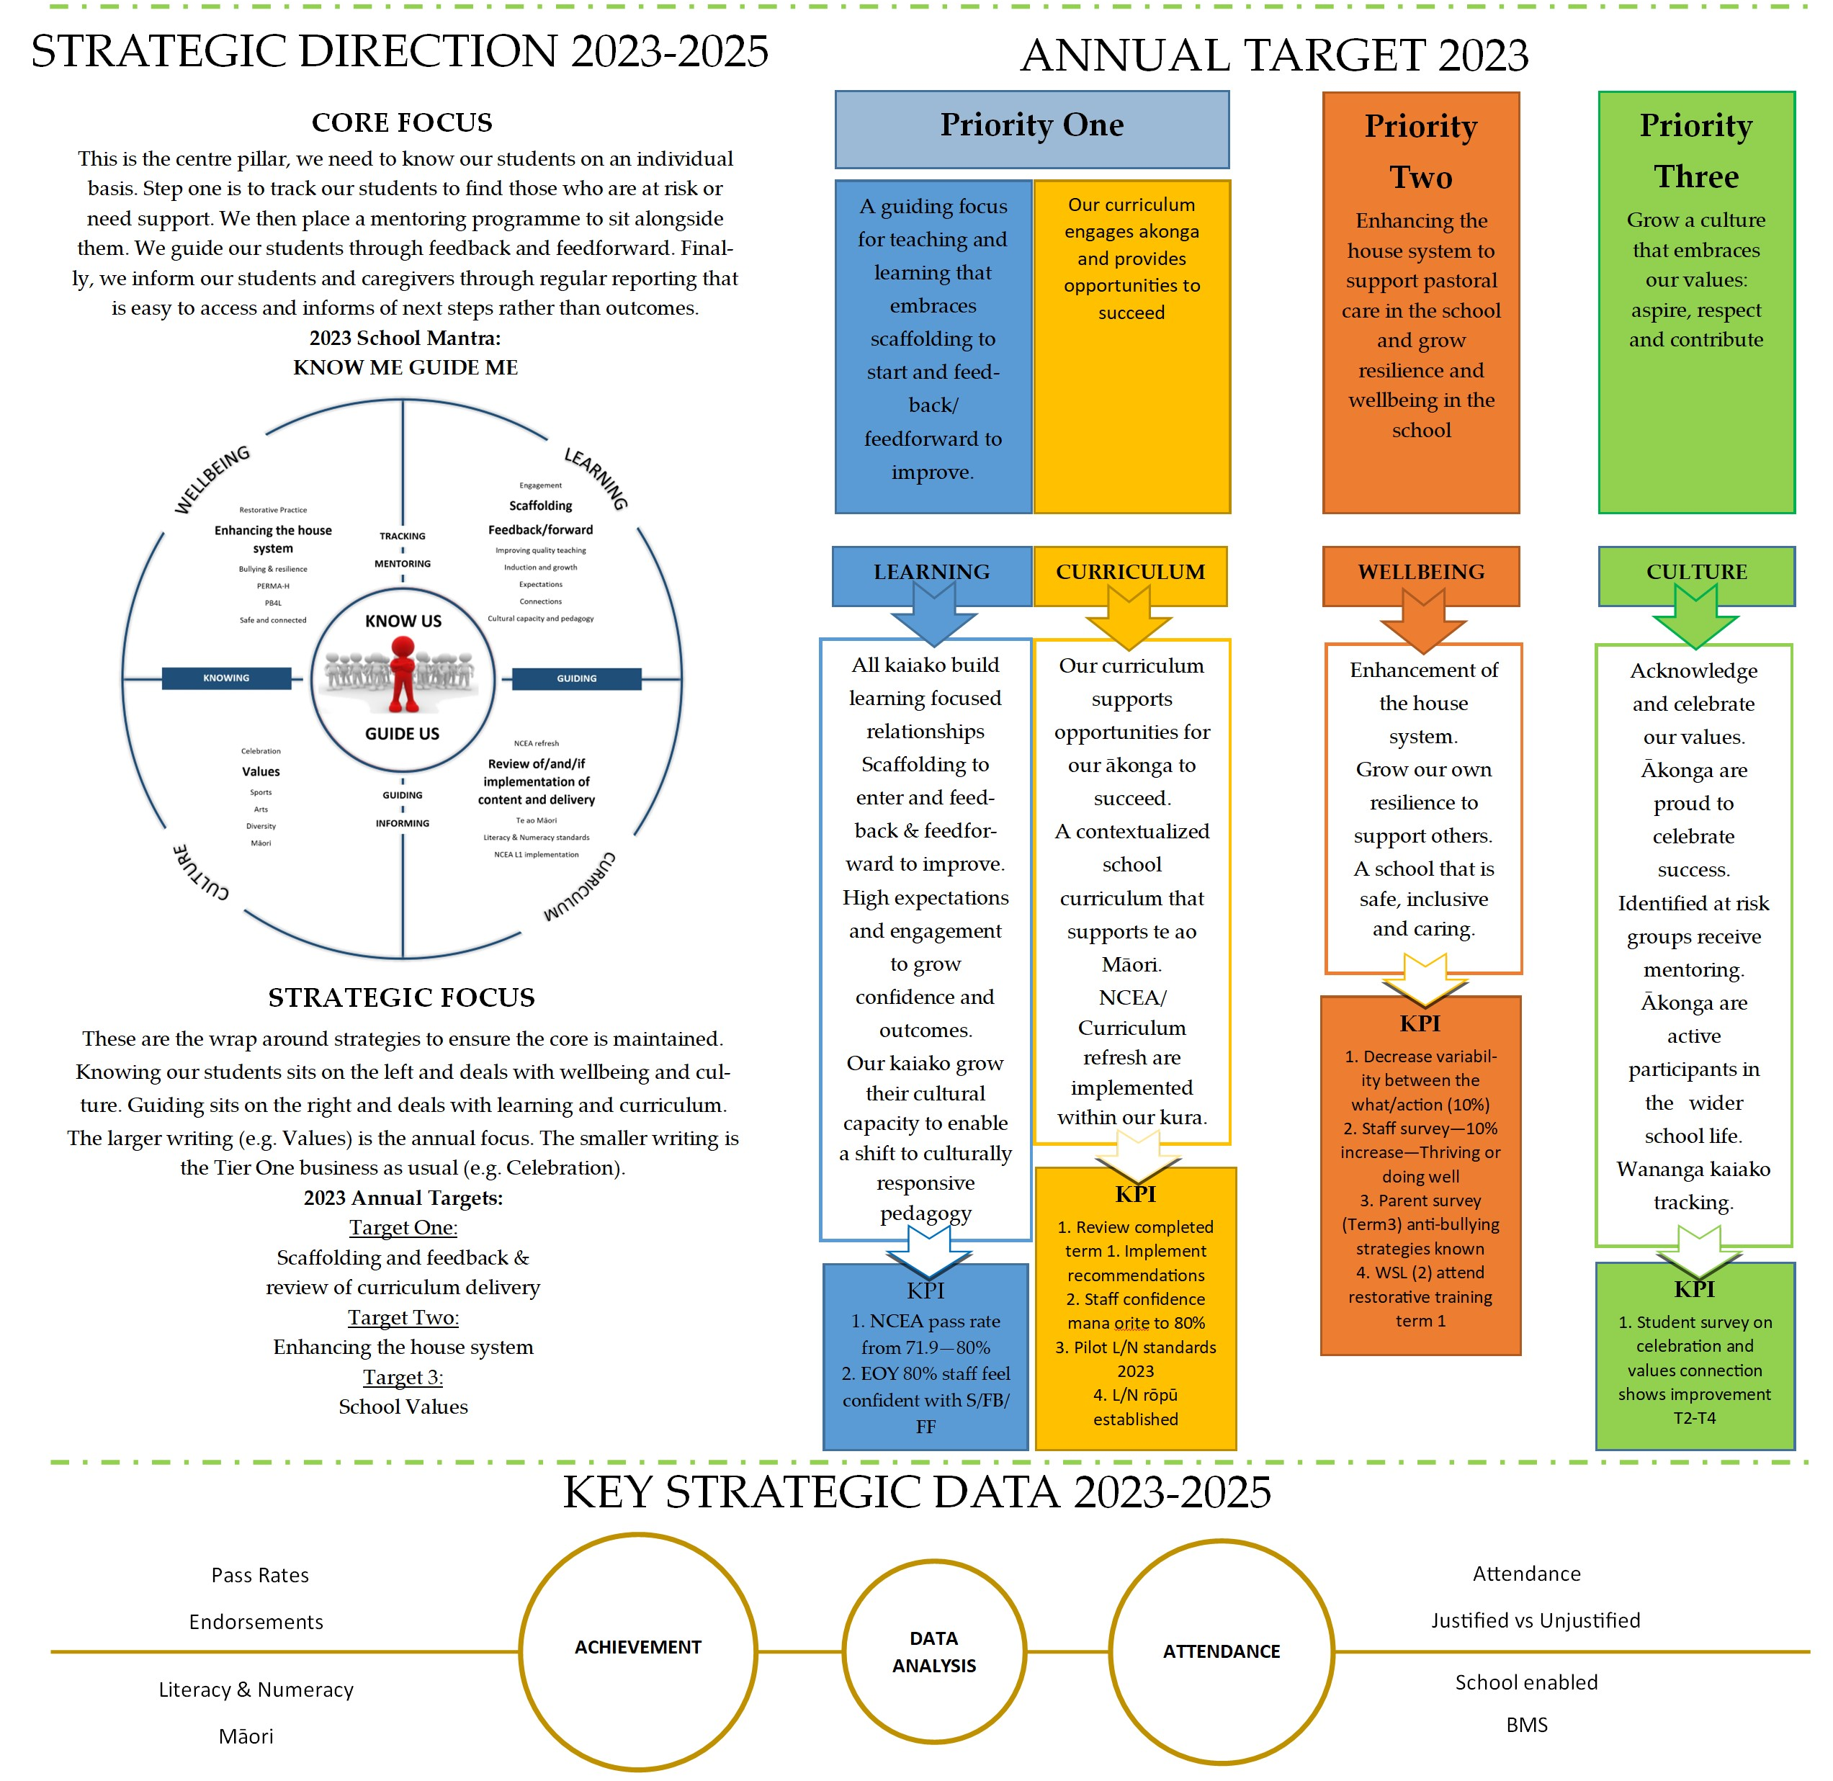

PART TWO:
DATA ANALYSIS 2023 SCHOOL YEAR (PROVISIONAL)

KEY STRATEGIC DATA
- Achievement | - Attendance | - Leavers
- Pass Rates  - Endorsements  - Literacy & Numeracy  - Māori | - Overall  - Māori  - Gender  - Non-Attendance | - All Leavers  - Māori Leavers
Overview

- Key Strategic Data
- Achievement
  - Pass Rates
  - Endorsements
 | Pass Rate |  |  |  | Merit |  |  |  | Excellence
 | 2022 | 22 EQI | 2023 | 23 EQI | 2022 | 22 EQI | 2023 | 23 EQI | 2022 | 22 EQI | 2023 | 23 EQI
Level One | 72.5 | 69.9 | 69.2 | 64.3 | 26.0 | 29.7 | 26.7 | 30.0 | 12.8 | 15.7 | 14.7 | 13.4
Level Two | 73.8 | 81.3 | 75.7 | 78.5 | 22.1 | 21.5 | 16.1 | 21.1 | 10.6 | 13.0 | 6.9 | 11.3
Level Three | 74.8 | 73.7 | 65.8 | 73.5 | 29.7 | 23.3 | 26.0 | 23.0 | 12.0 | 12.3 | 7.6 | 11.4
UE | 51.7 | 56.8 | 49.2 | 54.3

  - Literacy & Numeracy
 | Pass Rate
 | 2022 | 22 EQI | 2023 | 23 EQI
Literacy | 87.7 | 86.9 | 87.1 | 87.1
Numeracy | 85.3 | 84.4 | 90.9 | 85.3

  - Māori Pass Rates
 | Māori |  |  |  | School
 | 2022 | 22 EQI | 2023 | 23 EQI | 2023 | 23 EQI
Level One | 62.3 | 61.6 | 60.4 | 55.2 | 69.2 | 64.3
Level Two | 68.6 | 73.9 | 66.0 | 72.7 | 75.7 | 78.5
Level Three | 72.7 | 63.0 | 56.5 | 64.0 | 65.8 | 73.5
UE | 54.5 | 41.9 | 39.1 | 39.8 | 49.2 | 54.3

- Attendance
  - Overall
Term Three attendance is the critical term where attendance traditionally falls away as the pressure of schooling and NCEA increases. The government states that regular attendance is at or above 90% attendance. The graph below shows that our Year 9 attendance for Term 3 of 2023 is:
- Almost 50% of our Year 9 cohort attended at least 90% of the time. 100% attendance is approximately 200 days (40 weeks x 5 days). If a student has 6 days off in Term 3, they fall out of regular attendance. With COVID still in place, less resistance to colds and flu, and the increase in travel overseas (parents often take children out during term time) it would not take long for this number to grow past 6 days.
- Our percentage of attendance is higher than the averages for:
  - Year 9 – All Canterbury High Schools, NZ Co-ed schools, All NZ High Schools
  - Year 10 - NZ Co-ed schools, All NZ High Schools
  - Year 11 - NZ Co-ed schools, All NZ High Schools
  - Year 12 - All Canterbury High Schools, NZ Co-ed schools, All NZ High Schools
  - Year 13 - All Canterbury High Schools, NZ Co-ed schools, All NZ High Schools
- Our focus area for 2024 should be at:
  - Year 11 – This is the year of concern as it is first year of NCEA
  - Year 12 – This is the lowest performing cohort for regular attendance
- The school believes that by not accepting the poor support from the Ministry of Education and instead hiring our own attendance officer, we managed to make a real positive change in this area.
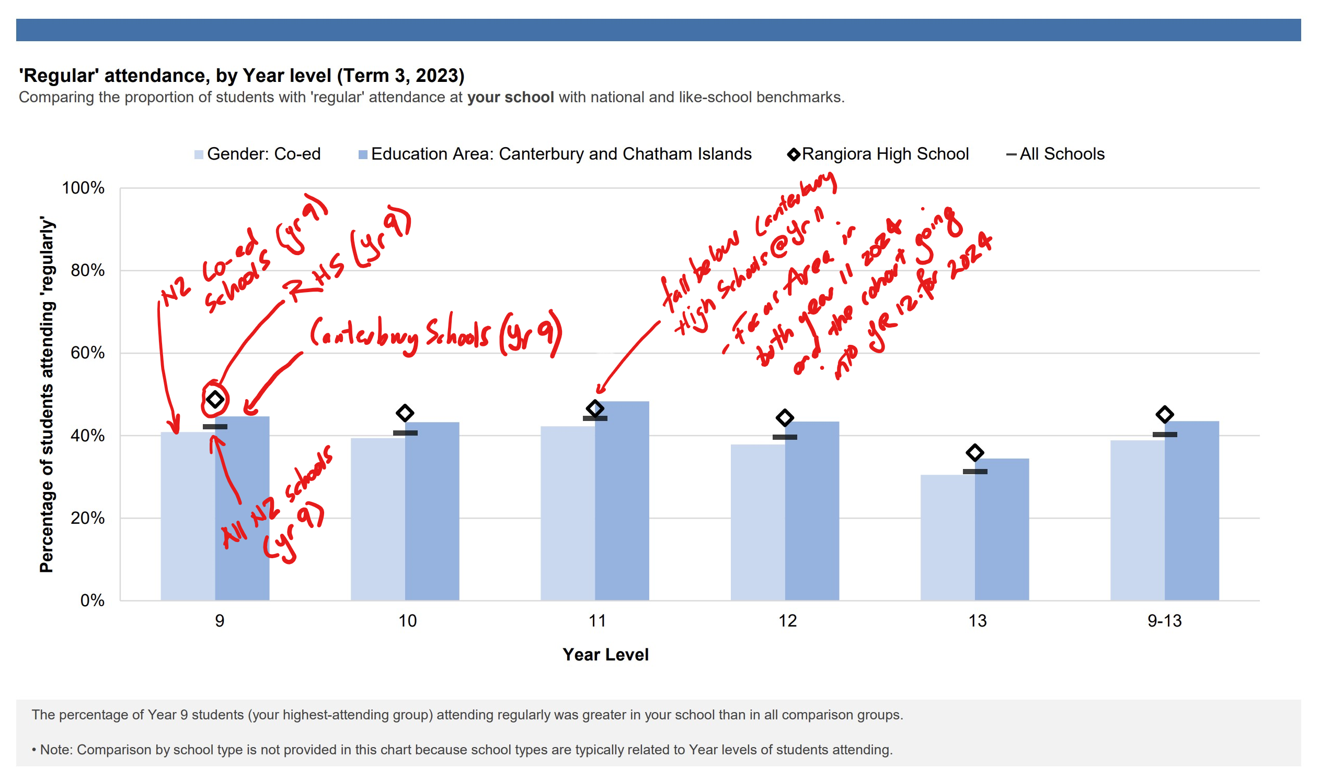
The following is based on Māori, male, female and non-gender specific. Māori and non-gender specific are two key areas of at-risk students that we track as regular attendance is one of a number of points in our tracking.

  - Māori – The statistics here change to include Primary Schools. The best benchmark is comparing against all students at RHS and against all secondary schools. Our results are:
  - All RHS vs Māori – Māori statistics are lower (38%) compared to all students (45%). We are connected to a number of agencies that are working at lifting attendance by working closely with whānau.
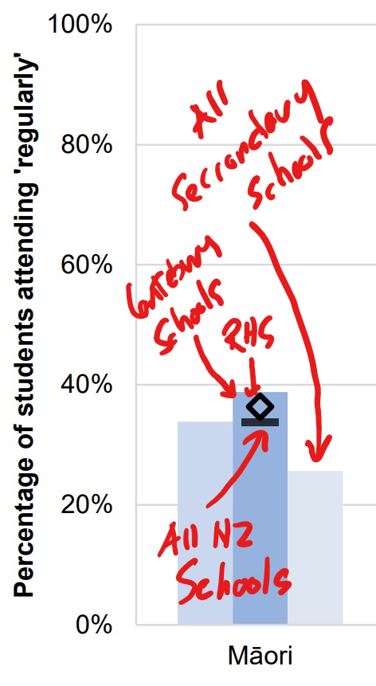

  - Gender – This has provided some very interesting results:
  - Boys have the highest attendance, greater than secondary and in fact all NZ schools
  - Girls are lower than boys by approximately 5% yet higher than secondary schools
  - Other – this is a real focus for us as we see that our ‘another gender’ students are well below all other measures
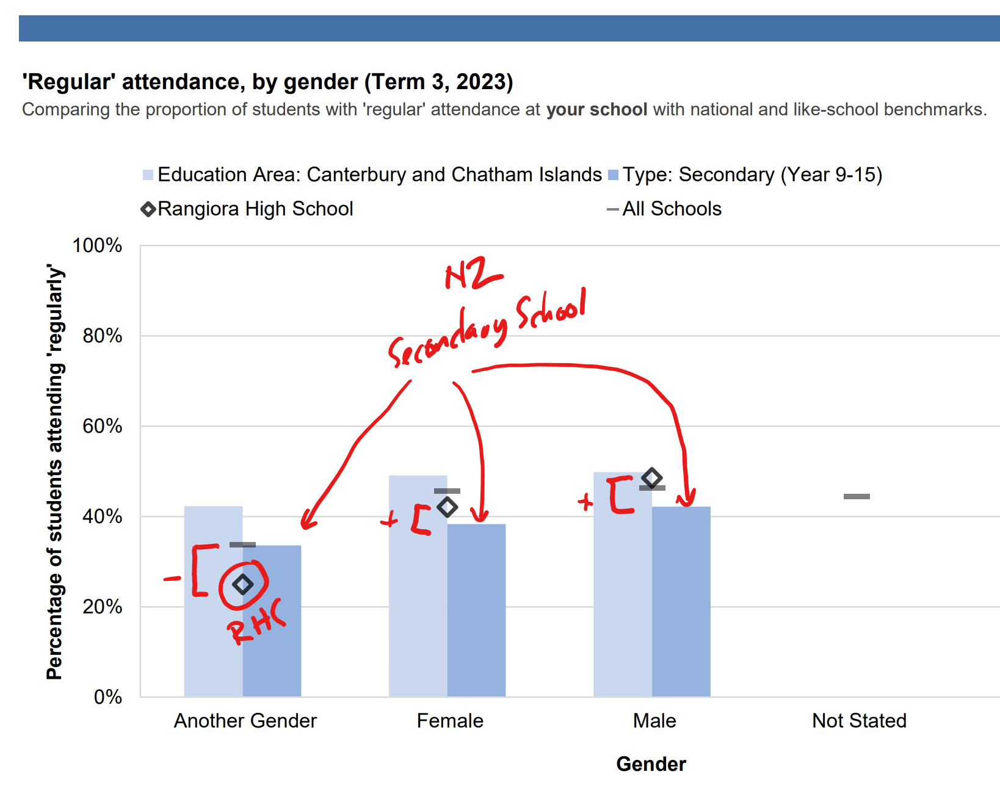

  - Non-attendance
60% of our non-attendance is justified but still absent. The majority of this is due to illness (51.6%). Unjustified is mainly Unknown and this is a KAMAR issue where that Unknown should have shifted to Truant meaning that 27.9% of our non-attendance is Truant.

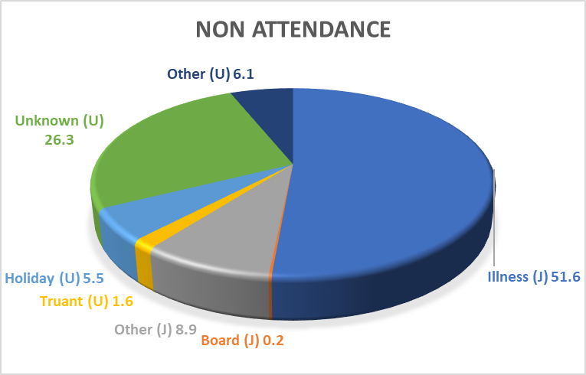

Our board enabled absence deals with suspension and stand downs. These have been high in 2023, like every school in Canterbury and with the refocus on restorative practices, we should see this decrease over the next few years. The next step is to analyse the referral process for our students and the impact this has on attendance of classes.

 | Stand Down | Suspensions
Other | 1 | 0
Māori | 11 | 4
NZE | 19 | 8
Year 9 | 5 | 6
Year 10 | 21 | 3
Year 11 | 4 | 1
Year 12 | 1 | 1
Year 13 | 0 | 1

- Leavers Data
Leaver’s data takes some time to create and we do not see the 2023 results for some time, thus we use the previous year’s data. Using the table below we have years 2018-2022. Each row relates to how many leavers left our school with at least Level one, then at least Level two etc. They are divided into All Rangiora students and compared then to Māori students. Using 2018 as the comparison year, each cell is highlighted against 2018 for either improve (green), neutral (yellow) or decrease (red). It is not a comparison from year to year.

 |  | 2018 | 2019 | 2020 | 2021 | 2022
With Level One | RHS | 94 | 91 | 88 | 87 | 87
 | Māori | 84 | 70 | 83 | 76 | 82
With Level Two | RHS | 83 | 79 | 78 | 76 | 74
 | Māori | 73 | 60 | 68 | 63 | 70
With Level Three | RHS | 49 | 51 | 51 | 43 | 49
 | Māori | 33 | 35 | 39 | 32 | 43
With UE | RHS | 36 | 37 | 39 | 31 | 33
 | Māori | 22 | 22 | 22 | 29 | 32
This is a concern with both All Students consistently tracking down and Māori consistently lower that All Students

  - All students:
  - Students leaving with at least Level One has been on a decline since 2019 from 94% to 87%
  - Leavers with at least Level One or Two is completely red.
  - Level Three has mainly been positive or at least neutral. Level Three and UE is the one year where the students have full year courses.
  - Māori:
  - Māori are consistently leaving with lower qualifications when compared to all students
  - Generally speaking, these levels are trending upward and the gaps are closing

- Overview
Our results from last year tell us a similar story to the previous years. It is important to note that we created strategies that we believe should improve academic outcomes for students, including full year courses and increasing subjects in Year 11 and 12 back to six, but these are implemented for the 2024 school year. One of the main focuses for our school was around tracking our students, specifically at Year 11 to allow us to respond to need. Although our pass rate has fallen, we did better in Year 11 (our focus year) than the other years. It is important to make sure that tracking our students continues to strengthen in 2024.
At Year 11 and 12, we were better than the national average (Year 11 69.2:60.0 – Year 12 75.7:72.2) but not Year 13 (Year 13 65.8:66.2). This was not the case with the comparison to our Equity Index School (EQI) where only Year 11 was stronger (Year 11 69.2:64.3). It should be noted that nationally our statistics are well below where they should be and it is difficult to argue the impact of COVID on sustained learning, especially considering that this is the group that is most affected.
Literacy and Numeracy continue to be strong against the EQI (Year 11 L 87.1:87.1 Year 11 N 90.9:85.3) and this is extremely positive at it sets the ceiling for the maximum pass rate. There needs to be some more unpacking of this data as our ceiling is 87.1 yet our results were 69.2. This essentially means the greatest barrier for our school is not Literacy and Numeracy but rather credit accumulation which I believe is not the ‘normal’.
Our endorsements need some work with only 2/6 above the EQI, yet once again the Year 11 cohort did the best in this area.
Māori results were not as strong as 2022 where 2/3 year levels were stronger than the EQI and only 1/3 were stronger in 2023 (again at Year 11). Our Māori results were better than the National Average but still 9% less than our All Rangiora student results. They should at least be the same.
Attendance (we use Term 3 as our benchmark as this is the most difficult term) was strong across all year levels in 2023, although it did not feel that way at school. In every year level we had higher attendance rates than both the National Secondary Schools figure and the National Co-education figures. I believe we need to rewrite the rhetoric that the Government has been feeding our communities. About half our students attended at least 90%, to put that in perspective, you fall out of this category if you have more than 6 days off in one term. This could be easily done by staying at home with COVID and knowing that 51.6% of our non-attendance is illness the picture changes very quickly. There are two key groups though that we need to focus on: 1. Māori have a lower attendance rate (38%) and 2. Non-gender specific runs at 25% while the average for NZ schools is about 32%. Some unpacking is needed here.

- Key Performance Indicators
- Analysis of Variance
 | Focus | Expectations | KPI | Outcome
Learning | A guiding focus for teaching and learning that embraces scaffolding to start and then feedback/feedforward to improve | All kaiako build learning focused relationships through scaffolding and feedback/feedforward.  High expectations and engagement to grow confidence and outcomes.  Our kaiako grow their cultural capacity to enable a shift to culturally responsive pedagogy | NCEA Level One pass rates from 71.9 to 80% | Not Met  70% pre-March figures
 |  |  | EOY 80% staff feel confident with S/FB/FF | Not Met  Staff at 4 or 5 confidence:  70.5% felt confident
 |  |  | Pilot L/N standards | Met
Curriculum | Our curriculum engages ākonga and provides opportunity to succeed | Our curriculum supports opportunities for our ākonga to succeed.  A contextualised school curriculum that supports te ao Māori.  NCEA/curriculum refresh are implemented. | Review of teaching and learning | Met  Completed Term One
 |  |  | Staff confidence with mana orite to 80% | Not Met  Staff confidence with mana orite shifted from 43% in Term 1 to 60% in Term 4
 |  |  | Pilot L/N standards | Met  Completed
 |  |  | L/N rōpū established | Met  Completed
Wellbeing | Enhancing the house system to support pastoral care in the school and grow resilience and wellbeing | Enhancement of the house system.  Grow our own resilience to support others.  A school that is safe, inclusive and caring. | Decrease variability between the what/action by 10% | Not Met
 |  |  | Staff survey 10% increase in thriving/doing well | Met  Staff who describe themselves as Consistently Thriving increased from 7.2% in 2022 to 20.8% in 2023
 |  |  | Parent survey shows strategies known re bullying | Not Met  It is difficult finding just one “package” that meets our needs and we are evaluating a multiple prong approach.
 |  |  | WSL (2) attend restorative action | Met
Culture | Grow a culture that embraces our values | Acknowledge and celebrate our values.  Ākonga are proud to celebrate success.  Identified at risk groups receive mentoring.  Ākonga are active participants in the wider school life.  Wānanga kaiako tracking in Year 11. | Student survey on celebration and values connection shows improvement over terms 2-4. | Not Met  Survey not completed

- Annual Target Review and Recommendations
TEACHING AND LEARNING
Target evaluation:
The key critical target that centred on student achievement (80% pass rate at Level One) was not achieved. Nationally NCEA results were well down with only 60% achievement across the country in Level One. Rangiora was well above both National and EQI averages at 70% but well below our target of 80%. A number of strategies were implemented (TOP programme, Tracking, and Literacy and Numeracy support) and yet to be implemented (single semesters and learning environments). Our learning has been immense and we now need to shift this to improving outcomes for our students from 2024. The confidence survey showed a great positive shift and highlighted that we have some more to do in the area of feedback/forward and scaffolding. The piloting of the new Literacy and Numeracy standards was a resounding success other than NZQA failing to enable the smooth operation of these examinations. 61% of our Year 10 students achieved Reading and 58% achieved Writing.

Recommendations for 2024:
- Continue to track student progress and identify at risk students for the TOP programme.
- Tighten the ability to withdraw students from standards. This was an area of concern (surprisingly) that was highlighted in 2023 and needs to be adjusted so that our students have the potential to succeed from the start.
- Continue to work on supporting teachers on their understanding and implementation of scaffolding and feedback/feedforward
CULTURE
Target evaluation:
In 2023 we made some momentous leaps in culture and sport. Assemblies had a clear plan connected to our values and often had a celebration of music or dance. Academic assembles and celebrations were created and led by the two student captains with a great deal of success and sustainability. The PB4L model was updated and used extensively by our teachers. Whilst we made some progress in staff culture, there is still some work to do, especially around the belief that we are more willing to talk about someone than to them. There was a large surge in sports and this created its own problems, albeit for a good reason, with respect to relying more on outside coaches who were not familiar with our expectations. We began to rectify this with work on expectations and support for coaches.

Recommendations for 2024:
- We need some real data to enable decision making on a culture from both staff and student.
- Continue to grow and understand our culture through our school values, sports, arts and diversity.
- Creation of a strong sense of belonging – Te Ao Māori

CURRICULUM
Target evaluation:
The year began with a full review of our teaching and learning structure and environment. This was the first step in a key 2-year review of curriculum and pastoral (2024). ImpactED was employed to review. The review was then used to inform decision making via two teams of staff of about 20 each. The outcomes of the two teams were then consolidated by a rōpū of 4 staff who made clear recommendations to SLT for implementation. We are proud of this process, as it was ‘by the people, for the people’ and enacted the review key findings from the community, students and kaiako. The review dealt with semesters, modules, wānanga and the environment. Changes were made across the board including the removal of semesters, reduction in both modules and wānanga, and the building of classrooms in Rakahuri.
We still have some work to do with Mātauranga Māori where our confidence levels fell short (60%) of our target (80%). Our Literacy and Numeracy rōpū is well underway and we are excited about what we will see in this area.
Recommendations for 2024:
- Review in 2024 the implementation of the changes to curriculum made as a result of the 2023 review.
- Work with Middle Leaders to support them to grow confidence in leading their teams in embedding Mātauranga Māori in their curriculum. This will be evidenced in Unit Planning.
- Scaffolding - Year 11 Unit Plans must include explicit methods of scaffolding.
- Literacy and Numeracy rōpū to continue in 2024.

WELLBEING
Target evaluation:
Decreasing variability was not met (10%). It became very apparent that there was a significant discrepancy between What/Actions, and this discrepancy occurred at multiple levels. The setup within KAMAR in terms of selectable options also made this consistency difficult. A consistent presence at House pastoral meetings, and amended documentation has assisted this as the year has progressed. It was pleasing to see that our staff who described themselves as Consistently Thriving increased from 7.2% in 2022 to 20.8% in 2023, and at the same time staff who described themselves as really struggling dropped from 17.4% in 2022 to 5.6% in 2023. There needs some more unpacking of our anti-bullying strategies, and we are pleased to have actioned Stymie into school. The restorative training was a success and we look forward to implementing this across the school next year.

Recommendations for 2024:
- Full review of the pastoral system as a whole
- Continue to work on consistency across the houses
- Continue to refresh and grow our restorative practices

PART THREE:
STRATEGIC REVIEW AND SHIFT 2024
At the end of 2023 the strategic leadership team reviewed and evaluated the strategic direction and made the following minor changes:

NO CHANGE

Shift to pastoral system
Shift from enhancing to full review
Embed this focus
Refocus and shift to culture
Completed
Refocus and shift to culture
Combine and lift to strategic goal 2024
Grow
Increase this focus

2023

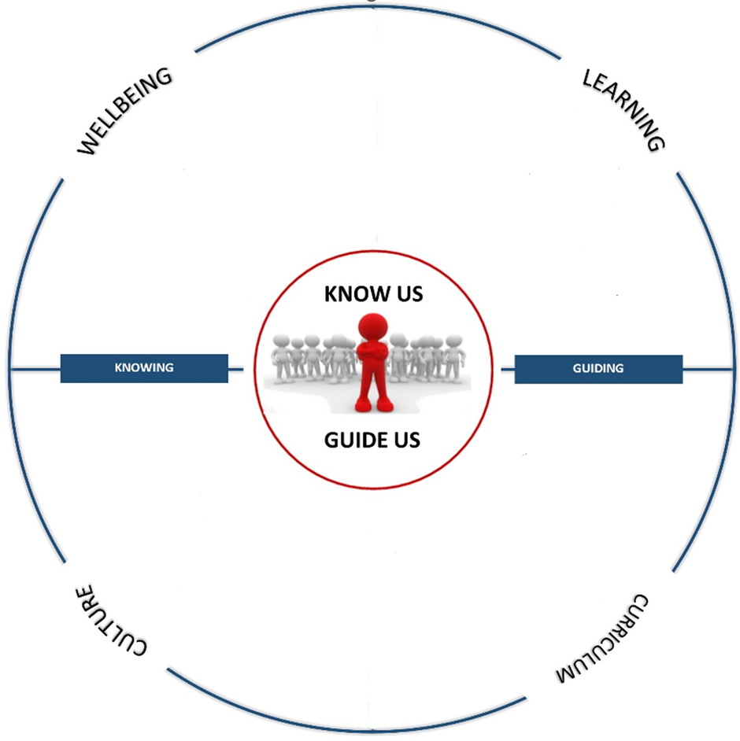
Quality Teaching & Learning
Scaffolding/FB/FF – High Expectations – Strong Engagement – Believing Mindset

2024
Review of the pastoral systems
Restorative Practices
Resilience – PERMA-H – PB4L
Safe – Connected –
Known

Induction and Growth

Understanding our Curriculum
School Values
Sports – Arts – Culture - Diversity
NCEA Refresh - L1 NCEA -
Literacy/Numeracy
Sense of Belonging
Te Ao Māori – Mātauranga Māori
Te Ao Māori – Achievement – Celebration

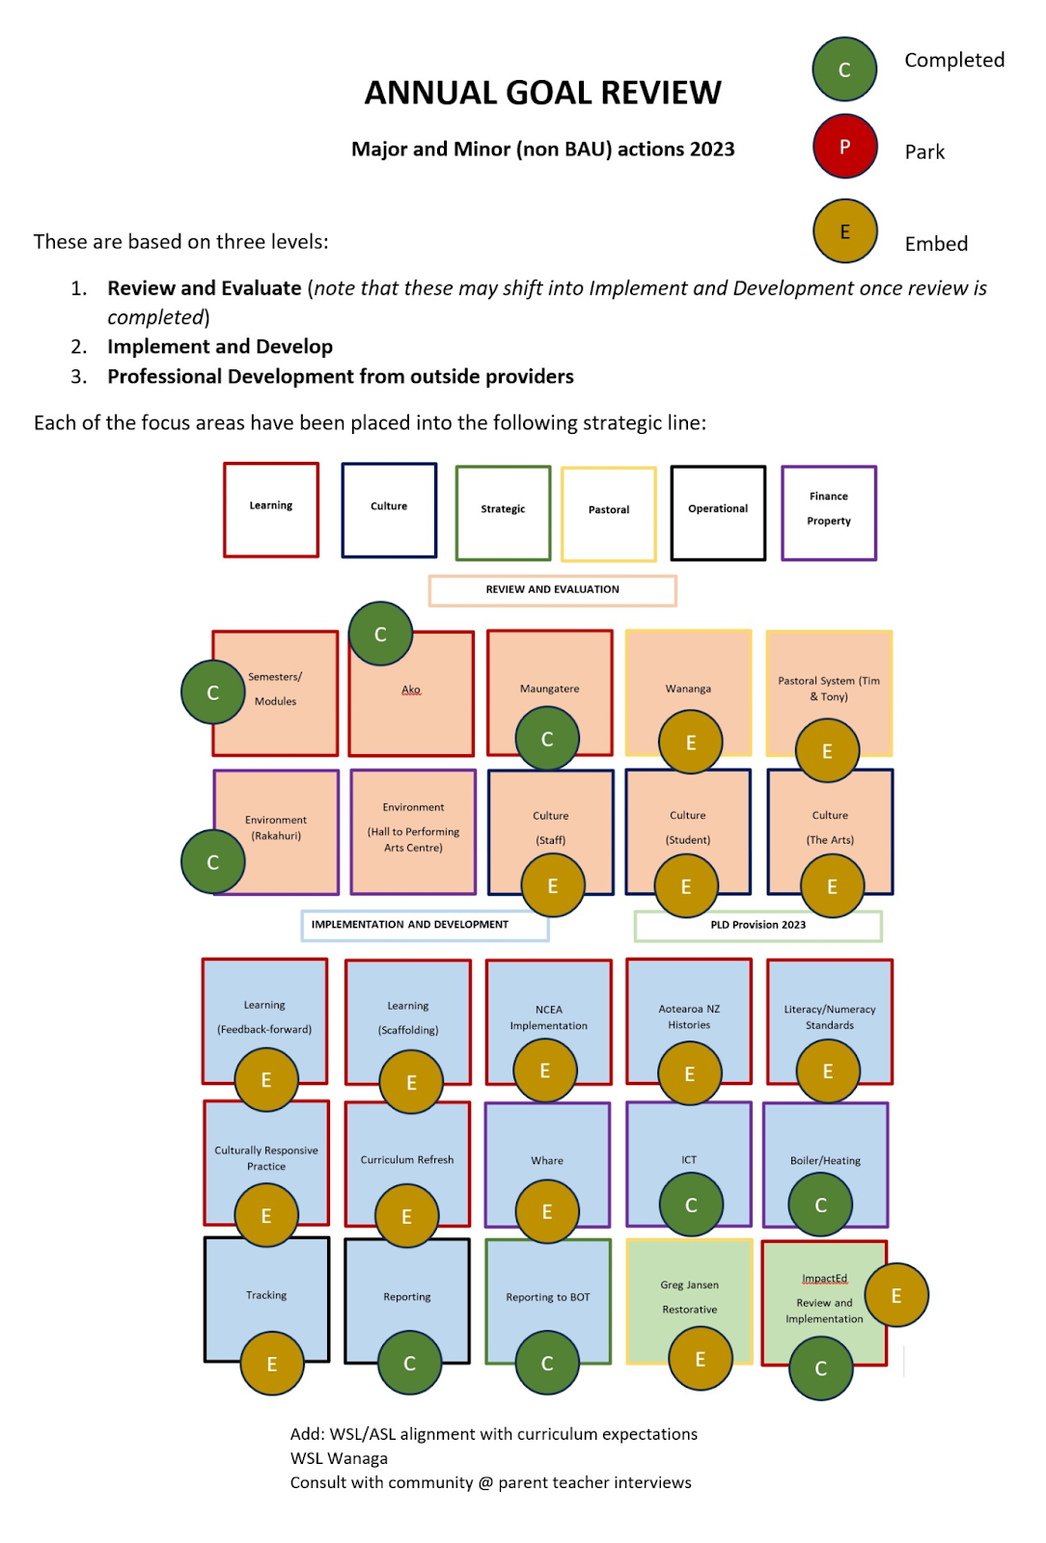

PART FOUR:
ANNUAL GOALS & TARGETS 2024
Three areas of annual goal:
      - REVIEW & EVALUATE
      - IMPLEMENT & DEVELOP
      - PROFESSIONAL DEVELOPMENT

REVIEW & EVALUATE
FULL PASTORAL REVIEW
NEW WĀNANGA REVIEW

CULTURE REVIEW STUDENT

CULTURE REVIEW STAFF

CULTURE REVIEW ARTS

HALL TO PERFORMING ARTS

IMPLEMENT & DEVELOP
TRACKING

LEARNING FEEDBACK-FORWARD SCAFOLDING

NCEA REFRESH

AOTEAROA NZ HISTORIES &
CURRICULUM REFRESH

CULTURALLY RESPONSIVE PEDAGOGY

LITERACY AND NUMERACY

PROFESSIONAL DEVELOPMENT

impactED LEARNING

Jansen RESTORATIVE

2024 ANNUAL TARGETS
KPI
- Tracking completed
- PR @ 80%

Priority One
A guiding focus for teaching and learning that embraces scaffolding to start and feedback/feedforward to improve
All kaiako build learning focused relationships
Scaffolding to enter and feedback & feed forward to improve.
High expectations and engagement to grow confidence and outcomes.
Our kaiako grow their cultural capacity to enable a shift to culturally responsive pedagogy
LEARNING
2024
- Track student progress and identify at risk students for the TOP programme
- Tighten the ability to withdraw students from standards. This was an area of concern that was highlighted in 2023 and needs to be adjusted so that our students have the potential to succeed from the start
- Continue to work on supporting teachers on their understanding and implementation of scaffolding and feedback/feedforward

KPI
- Review completed
- Restorative implemented
Enhancement of the house system.
Grow our own resilience to support others.
A school that is safe, inclusive and caring.
Priority Two
Enhancing the house system to support pastoral care in the school and grow resilience and wellbeing in the school
WELLBEING

2024
- Full review of the pastoral system as a whole
- Continue to work on consistency across the houses
- Continue to refresh and grow our restorative practices

KPI
- Wellbeing survey on belonging shows

Acknowledge and celebrate our values.
Ākonga are proud to celebrate success.
Identified at risk groups receive mentoring.
Ākonga are active participants in the wider school life.
Wananga kaiako tracking.
Priority Four
Grow a culture that embraces our values: aspire, respect and contribute
CULTURE
2024
- We need some real data to enable decision making on a culture from both staff and students
- Continue to grow and understand our culture through our school values, sports, arts and diversity
- Creation of a strong sense of belonging – Te Ao Māori

KPI
- L1 refresh including plans and units
Priority Three
Our curriculum engages ākonga and provides opportunities to succeed
CURRICULUM
Our curriculum supports opportunities for our ākonga to succeed.
A contextualized school curriculum that supports te ao Māori.
NCEA/Curriculum refresh are implemented within our kura.

2024
- Review in 2024 the implementation of the changes to curriculum made as a result of the 2023 review
- Work with Middle Leaders to support them to grow confidence in leading their teams in embedding Mātauranga Māori in their curriculum. This will be evidenced in Unit Planning
- Scaffolding - Year 11 Unit Plans must include explicit methods of scaffolding
- Literacy and numeracy rōpū to continue in 2024

PART FIVE:
ADDITIONAL COMPLIANCE REPORTING 2024
- Giving effect to Te Tiriti o Waitangi
Atawhai ngā rito, kia puāwai ngā tamariki.
Ako i ngā tamariki, kia tu tāngata ai, tātou katoa.

Cherish and nurture the shoots, so the children will bloom.
Learn from and with these children, so that we all can stand tall.

Executive Summary

MĀORI ĀKONGA
 | - Māori ākonga are 15.3% of the school roll
 | - Ākonga identify with 30 different iwi. 39% of our Ākonga Māori are Ngāi Tahu
CURRICULUM
 | - Te Reo and Kapa Haka offered from Year 9 - 13
 | - Numbers of ākonga taking te Reo and Kapa Haka are increasing in the junior school
ENGAGEMENT
Attendance | - Māori ākonga attendance sits 4.7% below the rest of our ākonga.
Pastoral | This is a key aspect of Whaea Renee’s position. As part of her kaiārahi role she spends one day a week focused on pathways for Māori working out of the Careers Department.  - In 2023 Amber Goldsworthy was appointed Kaitiaki Te Ao Māori
ACHIEVEMENT
NCEA | - Māori ākonga literacy and numeracy rates are lower than their peers  - In 2020 RHS was identified by NZQA as having made a significant difference in the achievement of Māori ākonga
Leaver Data | - Māori ākonga leaver rates are consistent or lower than all ākonga, however there was a pleasing improvement in 2022 at all levels
PROFESSIONAL DEVELOPMENT
Culturally Responsive Pedagogy | - The Kia Eke Panuku Strategic Lead Team, led by Amanda Peter [WSL] are driving the development of Cultural Relations for Responsive Pedagogy  - PLD contract with HTK focused on Mātauranga Māori  - A Teacher Only Day saw PLD on Mātauranga Māori  - Rongohia Te Hau continues to inform our next steps
PLD | - A variety of PLD in-house and through providers such as HTK  - New staff induction has a focused allocation to Culturally Responsive Pedagogy and the work of our Kia Eke Panuku team  - Many staff are currently learning or have been involved in learning Te Reo Māori through Te Wānanga o Aotearoa or the Ministry funded Te Ahu o Te Reo. The Level 1 course has been delivered at Rangiora High School. Teaching and support staff are enrolled  - We successfully applied for centrally resourced funding for support to integrate Mātauranga Māori into NCEA courses (a total of 100 hours) in 2022. This is coming to an end, so another application has been submitted with a focus on working with middle leaders  - In Term 1 - Russell Bishop delivered PLD to our Kāhui Ako focused on Teaching to the North East. 4 of our senior leaders also attended his workshop on Leading to the North East  - A number of staff have attended workshops presented by Ngāi Tūāhuriri  - On May 3-4 2023, Staff attended PLD with HTK focused on Mātauranga Māori  - On May 5 2023 - our entire staff had a focus on Mātauranga Māori as part of the Teacher Only Day  - We are investigating whole staff PLD for the beginning of 2024 on Te Tiriti.  - We have a PLD contract with HTK in 2024, with a focus on supporting middle leaders with Mātauranga Māori. On February 29 2024, all Leaders of Learning will be attending off site PLD.  - In 2024, the Deputy Principal - Curriculum and Teaching and Learning, intend as part of the school’s strategic plan to see evidence of Mātauranga Māori built into all Year 11 Unit Plans

Māori Ākonga Numbers and Movement

1st March Roll Return
On 1 March 2024 there were 259 Māori ākonga enrolled at Te Kura Tuarua o Rangiora (15.4% of the school roll).

 | TOTAL | Year 9 | Year 10 | Year 11 | Year 12 | Year 13
ALL | 1684 | 389 | 334 | 399 | 342 | 220
Māori | 259 | 72 | 49 | 65 | 40 | 33
Pasifika | 30 | 6 | 3 | 9 | 7 | 5

Iwi
Ākonga identify with 30 iwi. The four largest iwi groups are:
- 100 Ngāi Tahu
- 34 Ngāpuhi
- 16 Ngāti Porou
- 20 Not stated

Curriculum
Te Reo Māori and Kapa Haka are taught across all year levels.
- Year 9 is a module option (10 weeks) of 3 periods per week.
- Year 10 ākonga are offered a 20-week semester of 3 periods per week.
- Year 11- 13 are full year options of 4 hours per week
- Year 11,12,13 are in a combined class for Kapa Haka

Student Numbers | Year 9 | Year 10 | Year 11 | Year 12 | Year 13
Te Reo Māori | 149 | 58 | 34 | 9 | 6
Kapa Haka | 51 | 20 | 12 | 6 | 5

Two ākonga stood at Waitaha Manu Kōrero in Junior and Senior English and Senior Māori sections in 2023.

In the past year Kapa Haka classes have assisted at various events in school, including: Pōwhiri, ANZAC Day, Matariki celebrations and school assemblies. Ākonga also supported our speakers at Manu Kōrero. Our students participate in the local Kapa Haka festival every year. In the past they performed a full set of waiata, haka, mōteatea and poi which was admirable as their practice time was minimal. We have also been a pilot school for Level 1, 2, and 3 Te Ao Haka. Some of our student work has been used for Benchmarks.

Creating opportunities for kapa haka is one way that schools can increase their cultural responsiveness to Māori ākonga as Kapa Haka provides a learning environment that celebrates Māori culture and what it means to be Māori. The research shows that there are other associated benefits including:
- the recognition that, as Māori, they add value to New Zealand’s unique identity
- the embedding of Māori values (e.g. whanaungatanga, ako, tuakana-teina)
- increased confidence gained from ‘performance’
- an appreciation of the different dimensions that contribute to holistic well-being (hauora)
- an enhanced ability to communicate meaning through visual language e.g. action songs and haka
- physical stamina, fitness and coordination
- cognitive stimulation due to the demands of recitation, repetition and memorisation
- a sense of solidarity from being in a collective, as part of a team
- self-discipline and commitment
- exposure to leadership opportunities and role-modelling
- personal growth and development

Te Reo Māori and Te Ao Māori are more than a curriculum area; they are part of who we are as New Zealanders. The challenge for us, as a school, is how to integrate Te Ao Māori and Te Reo Māori through all learning areas. To ensure each ākonga’s prior knowledge and experience provides them the foundation from which new learning can build and potential can be released.

The second challenge for us is how we can more effectively work towards ending the disparities between Māori and Pakeha. How we can embed across learning areas, subjects and courses culturally and relationally pedagogies that engage our Māori ākonga and support them to achieve their potential.

A third challenge is to incorporate local curriculum across faculty areas as a foundation NOT as an add on.

Wānanga
All students have 1 hour of Wānanga every week, and 2 half hour sessions. In this context there are themes around Aotearoa New Zealand
“As a citizen of Aotearoa NZ, how can I engage with and contribute to our rich cultural diversity?”

Content around Matariki, Te Wiki o te reo Māori are explicitly delivered, in addition there are exploration into weekly Whakataukī

Tīkanga in Wānanga
- Tīkanga of Wānanga is co-constructed in a mission statement and class treaty with the rōpū
- Te Koru Class Treaty
- Te Arahua Class Mission Statement
- Te Pae Tawhiti overview and introduction - to lead into kōrero (please note, this comes with the flexibility of the class constructing this (agentic)).
- Use of karakia - open Wānanga at the beginning of the week and close at the end of the week.
- Kaiako will use the correct pronunciation of ākonga names
- Whakataukī will be used to support the major themes/topics in Wānanga - kōrero or activities will be designed by kaiako to embed the Whakataukī across the learning of the topic. These can be found in the teacher planner.
- Waiata can be used as part of the Wānanga programme. For example, there are waiata available through Mātauraka Mahaanui that can support celebration of events
- Significant events and contexts that are important to a Mātauranga Māori and Te Ao Māori view will be given ‘space’ and priority for learning in Wānanga, for example, (not an exhaustive list):
  - Matariki
  - Te Wiki o Te Reo Māori
  - Cultural narrative of Rakahuri

Progress and Achievement

Literacy and Numeracy 2023
All ākonga are required to achieve 10 credits at Level 1 in Literacy and Numeracy to achieve NCEA Level 1. At Rangiora High School in 2023:
- 86% of Year 11 Māori ākonga gained Level 1 Literacy (the rate for all Year 11 ākonga was 87.1%) The national rate for all Year 11 ākonga was 83.7%
- 86.8% of Year 11 Māori ākonga gained Level 1 Numeracy (the rate for all Year 11 ākonga was 90.9%). The national rate for all Year 11 ākonga was 81.3%

For University Entrance, ākonga are required to achieve 10 credits in Literacy. These can be achieved in Level 2, or if needed, in Level 3. At Rangiora High School in 2023:
- 56.5% of Year 13 Māori ākonga gained UE literacy (the rate for all Year 13 ākonga was 55.9%)

NCEA Level 1-3

NZQA’s Equitable Educational Achievement for Ākonga Māori Project - Phase 1
After reviewing nationwide data, our school was identified as having raised Māori achievement of NCEA Level 1 ākonga from 2017 to 2020. Unfortunately, since 2020, there has been a decline in our Māori achievement (this is consistent with the entire cohort and in many cases consistent with National results)

2023 NCEA Results

Level 1 - %
Year 11 | 2020 | 2021 | 2022 | 2023 | NATIONAL  2023
NZ European | 82.8% | 69.1% | 72.4% | 69.4% | 65.9%
Māori | 71.7% | 54.3% | 61.3% | 60.4% | 49.6%
Pasifika | 81.8% | 71.4% | 62.5% | 88.9% | 49.9%
Asian | 100% | 71.4% | 80% | 50% | 58.3%
Other | 100% | 50% | 100% | 100% | 5833%
Total | 82.9% | 69.6% | 71.9% | 69.2% | 60.0%

Level 2 - %
Year 12 | 2020 | 2021 | 2022 | 2023 | NATIONAL  2023
NZ European | 81.7% | 79.9% | 73.6% | 75.8% | 77.1%
Māori | 77.1% | 80.4% | 68.6% | 66% | 63.3%
Pasifika | 100% | 72.7% | 80% | 83.3% | 63%
Asian | 100% | 80% | 66.7% | 80% | 69.9%
Other | 100% | 0% | 0% | 50% | 73.3%
Total | 82.2% | 80% | 73.8% | 75.7% | 72.2%

Level 3 - %
Year 13 | 2020 | 2021 | 2022 | 2023 | NATIONAL  2023
NZ European | 68.9% | 65.8% | 74.7% | 66.3% | 69.9%
Māori | 59.3% | 50% | 72.7% | 56.5% | 54.8%
Pasifika | 80% | 42.9% | 50% | 50% | 58.1%
Asian | 70% | 85.7% | 66.7% | 71.4% | 68.7%
Other | 0% | 0% | 0% | 0% | 64.1%
Total | 69% | 65.6% | 74.4% | 65.8% | 66.2%

Mentoring and Support of Māori and Pasifika Ākonga
All Māori ākonga are supported by:
- Their Wānanga kaiako. This year, Year 9 ākonga enrolling from bilingual schools were given the option of joining a wānanga group specifically designed to support the ongoing learning of tikanga and Te Reo.
- We have a full time Kaiārahi Māori, Whaea Renee Tuhikarama (Tainui), supporting our Rangatahi Māori. This includes identifying ākonga at risk, working with some ākonga in class; learning conversations with ākonga regarding pathways, liaising with whānau. Renee also works in our Careers Department offering opportunities to tauira from external agencies, tertiary study, and work experience, promoting and following up on scholarships, courses and programmes for tauira. Renee helps coordinate whānau hui, liaises with our pastoral network, supports ākonga and kaiako at events as well as facilitating them.
- From March 13, Nicole Manawatu-Brennan and Raewyn Brown will join Rangiora High School on the departure of Renee.
- The pastoral network includes Teachers, Deans, Heads of House, Guidance Counsellors and Deputy Principals.
- In 2024 we appointed Amber Goldsworthy as Kaitiaki te Āo Māori - this included a creation of effectively a Māori Department in our kura. Her role includes overseeing the delivery of curriculum and ensuring oversight and pastoral care of our Māori ākonga. We see this as a very positive step forward for our kura.
- Paula McDonald, as Deputy Principal with responsibility for Teaching and Learning, has oversight of Māori ākonga engagement and attendance. Remihana Emery our Associate Principal is also supportive in this role.

Retention and Transition of Māori Leavers

Māori ākonga leaving Rangiora High School with NCEA Level 1 or above:
 | 2020 | 2021 | 2022 | 2023
Number | 34 | 31 | 46 | 32
% of total | 82.9% | 75.6% | 80.7% | 61.5%

Māori ākonga leaving Rangiora High School with NCEA Level 2 or above:
 | 2020 | 2021 | 2022 | 2023
Number | 28 | 26 | 39 | 25
% of total | 68.3% | 63.4% | 68.4% | 48%

Māori ākonga leaving Rangiora High School with NCEA Level 3 or above:
 | 2020 | 2021 | 2022 | 2023
Number | 16 | 13 | 24 | 12
% of total | 39.0% | 31.7% | 42.1% | 32%

Māori ākonga leaving Rangiora High School with University Entrance:
 | 2020 | 2021 | 2022 | 2023
Number | 9 | 11 | 18 | 8
% of total | 22.0% | 26.8% | 31.6% | 15.3%

Ākonga and Whānau Voice

Rongohia te Hau
This will be the 10th year using this process. Rongohia te Hau is a tool that gives schools a picture of their pedagogy. Rongohia te Hau co-constructs the process for understanding classroom practice across a school. The evidence that is gathered tells us how we can change pedagogy if we want to make more of a difference for our Māori ākonga, and as is often stated, what is good for Māori is good for all ākonga. The observations offer a snapshot - a slice in time - that provides a representative sample across the school that gives a picture of what the pedagogy could look like on any given day. The Kia Eke Panuku team visited approximately 35 teachers’ rooms to do a 20-minute observation. The classrooms are chosen randomly to give a good ‘slice’ of the school.

After the classroom walk-throughs the Kia Eke Panuku team’s shared learning conversations help us to reconsider the classroom pedagogy across a continuum from 1 to 5. Together, we group it according to classrooms where the evidence of relational and culturally responsive pedagogy was basic, where it was developing and where it was integrating. In our last Rongohia Te Hau walk-throughs this shift was evident and we are hoping to see that again in 2024.
Māori ākonga and their whānau and teachers are also surveyed.
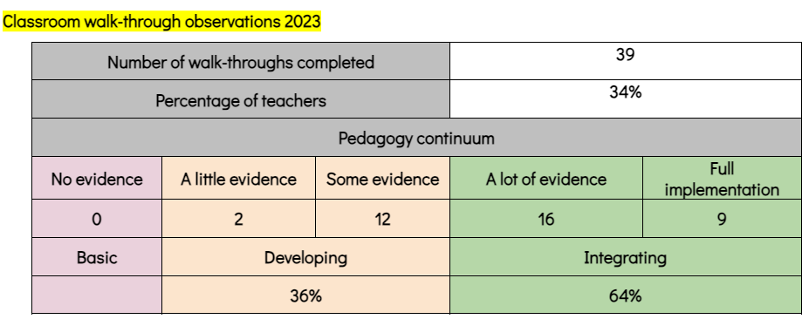
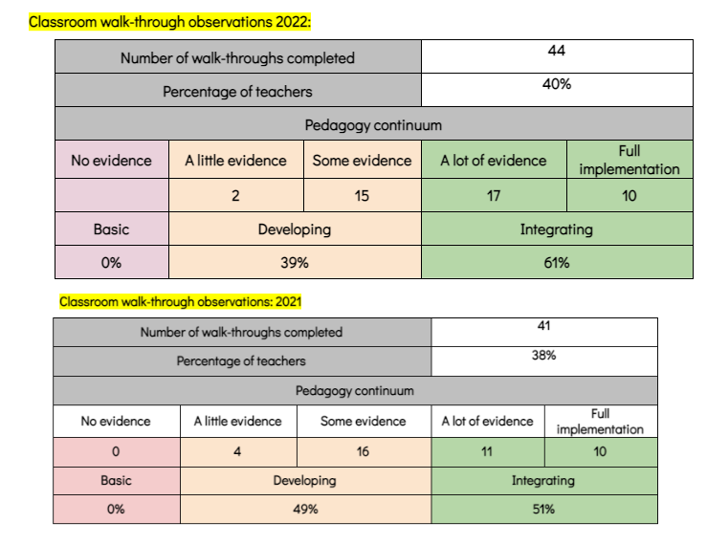

Ākonga Voice
Two senior ākonga attend weekly Wednesday meetings with the Kia Eke Panuku Strategic Change Lead Team. This is a regular opportunity for them to report back, ask questions, get information, or raise concerns.

These responses reinforce the need for the school’s ongoing commitment to culturally relational and responsive pedagogy through the mahi of the Kia Eke Panuku Strategic Change Leadership Team. We also gather ākonga voice through our Rongohia Te Hau annually. At the end of 2022 the KEP team spoke kanohi ki te kanohi to Year 9 and 10 rangatahi. This data formed the basis of the ‘Know Me, Guide Me’ focus in our Strategic Plan

Whānau Hui
Whānau Hui are scheduled once per term. Our first Whānau Hui was held on February 8th. In term 2, 2023, a special NCEA Whānau hui was held to support both our pasifika ākonga and whānau, it is our intention to offer this again in 2024. Typically, whānau hui are week 6 of every term. This year, our Matariki Celebration is on Wednesday June 26. This will be our fourth event since starting in 2021.
Staff
In 2023 we appointed Amber Goldsworthy as our Kaitiaki Te Ao Māori. Amongst her role, she oversees the delivery of our te reo Māori and Kapa Haka Programmes. Our kaiako are Whaea Kezia Lavea (Ngāiti tama te tau ihu) and our Kapa Haka kaiako are Whaea Raewyn Brown and Whaea Dee Teddy

9 other staff who identify as Māori are in the following areas:
- Drama, Visual Arts, English, Land-based Studies, International Department, Guidance Department, Māori Department
Professional Learning and Development

Kia Eke Panuku Strategic Change Lead Team
Amanda Peter leads this team. Their role being to develop cultural relations for responsive pedagogy. This team continues to meet each Wednesday morning. Two senior ākonga have joined the team. A website has been created. This shows what we are doing, news, readings and a whole lot more.

The team has also delivered whole staff Professional Learning for many years. The focus of this has included: Māori Ākonga Achievement, Gathering Culturally Responsive Student Voice, Our Cultural Toolkit and reviewing our Culturally Responsive Rangiora High School Continuum.

Shadow Coaching
The Kia Eke Panuku SCLT continues to nurture this kaupapa. This year we are again working with Waikato University: Karley Wilks-Forde. Shadow Coaching now occurs within faculties. Middle leaders have been trained in 2020 and 2021 on the kaupapa, including how to observe and how to have the Shadow Coaching kōrero. The Shadow Coaching method has seen a deepening of understanding of the Cultural Tool Kete and a shift in teacher practice (as seen in the Rongohia Te Hau data). This is now part of Faculty culture, in that all faculty administration occurs in a Culturally Responsive manner.

Te Reo Māori
Many staff have completed the programme, He Papa Tikanga, to learn Te Reo Māori and Tikanga. Staff are currently enrolled. This is an intensive self-directed programme.

Many staff are enrolled in Te Ahu o te Reo Māori learning programmes Levels 1 - 5. These programmes aim to grow and strengthen an education workforce that can integrate te reo Māori into the learning of all ākonga in Aotearoa New Zealand by 2025.

2021
- 65 Staff completed He Papa Tikanga through Te Wānanga o Aotearoa
- 17 staff enrolled in Te Ahu O Te Reo Māori
2022
- 19 staff enrolled in Te Ahu o Te Reo Māori.
- 6 staff at Learning Level 1, 6 at Level 2, 2 at Level 3 and 5 at Level 4.
- 1 one staff member enrolled in Level 4 Raranga
2023
- Numerous staff currently are enrolled in Te Ahu o Te Reo Māori
- 1 staff member enrolled in Level 5 Raranga
2024
- Many staff are currently enrolled in Te Ahu o Te Reo Māori.
- Staff continue to upskill on tikanga through He Papa Tikanga delivered by Te Wānanga o Aotearoa
- 1 staff member on study leave enrolled in Level 6 Raranga

Puketeraki Kahui Ako
Culturally Responsive Pedagogy is important in our Kāhui Ako. We have Across School Leaders working in this space including Shauna Henderson. Shauna has co-led a rōpū from across our Kāhui Ako called He Tipu. In 2023 this rōpū met 6 times in the year to progress their mahi. We have also released one of our Kia Eke Panuku team in the past to attend.

In 2023, 2 of our Within School leaders also worked in this space. Claire Aldhamland is leading a team of Kaiako, Whānau and ākonga on the Maro Project. They give their own time to make piupiu for our Kapa Haka rōpū. The sharing of knowledge and tikanga they commit to raranga is amazing.

Amanda Peter continues to lead our Kia Eke Panuku Team in 2024. This team consists of both kaiako and rangatahi. Their role is to develop cultural relations for responsive pedagogy. The team continues to meet every second Tuesday afternoon. The team has also delivered and lead whole staff Professional Learning. The focus of this is on Māori Ākonga Achievement and reviewing our Cultural Responsive Rangiora High School Continuum.

Te Wiki o te Reo Māori (Māori Language Week)
This is valued in our kura. Our students and kaiako work to make this a week of celebration. Our kura registers every year for the Māori Language Moment. Our whole kura stops and e tū for the Aotearoa New Zealand National Anthem.

Every year a kete of resources is produced and shared with all kaiako to support them to uphold Māori language within their Wānanga. All staff have the opportunity to participate in the Te Wiki o te Reo Māori quiz.

Our focus is that ‘every’ week is Te Wiki o te Reo Māori. In 2023 our Year 13 leaders took on the responsibility for driving our mahi in this area as a kura.

Mātauranga Māori
We successfully applied for centrally resourced funding for support to integrate Mātauranga Māori into NCEA courses, part of the required changes to NCEA (a total of 100 hours). The primary focus was on supporting the Physical Education and Mathematics faculties, however in May, 34 staff covering all faculties accessed one day workshops by our provider Chante Botica (HTK). In 2024 our RAPLD contract continues with HTK, centred around supporting our middle leaders. In 2024 our Leaders of Learning are working with HTK, their first PLD session was on 29 February 2024.

Staff briefings / meetings
Staff say karakia for our 2 morning briefings and some staff use karakia at other hui. Waiata are practised at Friday mornings briefing.

Self-Reflection
To support staff reflect on where they are at and their next steps, a self-reflection template has been developed. Staff are also encouraged to use this tool to self-reflect on their pedagogy

Other Supporting Documentation in kura (some is archived):
What steps are you taking to make instruction available to all your students in tikanga Māori and te reo Māori?
How well are you achieving equitable outcomes for Māori students?
- Sight policy
- Curriculum plan/overview - RHS Curriculum Policy
- Analysis of variance / analysis of achievement data
  - KIG - Māori Student Achievement Report
- Professional learning around Te Tiriti o Waitangi
  - Culturally Responsive PLD Plan 2022
  - PLD Application - DRAFT HTK MDP (successful)
  - RHS Puketeraki TRM Language Plan
  - Rongohia Te Hau Data 2023
  - Rongohia Te Hau Continuum Staff PLD 2022
  - CRRP Teacher Planner 2023
  - Bill Anderson Te Tiriti Workshop Term 3
  - PLD regularly with staff
- Other
  - Kia Eke Panuku - runnings
  - He Tipu (Kāhui Ako)
  - Language Acquisition Hui 5 November
  - Equitable Educational Achievement for Ākonga Māori Project – Phase 1
  - 2023 Tauira Māori.pdf
  - Gathering Student Voice - RTH
  - Local Curriculum and Tikanga Māori and Mātauranga Māori in Faculties 2023

- Statement of compliance with employment policy

Reporting on principles of being a good employer
Obligation to provide good and safe working conditions | Yes – including a health and safety office, staff wellbeing officer, EEO policies and procedures and regular surveys on wellbeing
EEO Programme and how it has been fulfilled | No
Impartial selection for applicants | Yes – all interviews are held with uneven panel numbers (from three interviewers. Ngai Tūāhuriri engaged in any culturally specific positions. Appointment policy in place and followed. All interviews recorded with question number system.
Recognising  - Aims and aspirations of Māori  - Employment requirements of Māori  - Greater involvement of Māori in the Education sector | See EEO policy attached
Enhancing the abilities of individual employees | School wide PLD and individual growth PD including the ability to retrain (school supported). (Currently one teacher and one counsellor)
Recognising the employment requirements of women | See EEO policy attached
Recognising the employment requirements of persons with disabilities | See EEO policy attached

Reporting on EEO
Do we have an EEO policy? | Yes
Does it include training to raise awareness of issues which may impact EEO? | No
Is there someone appointed to coordinate compliance? | Yes
Does it provide for reporting on compliance? | Yes
Does it set priorities? | No

PART SIX:
STRATEGIC PLAN 2024
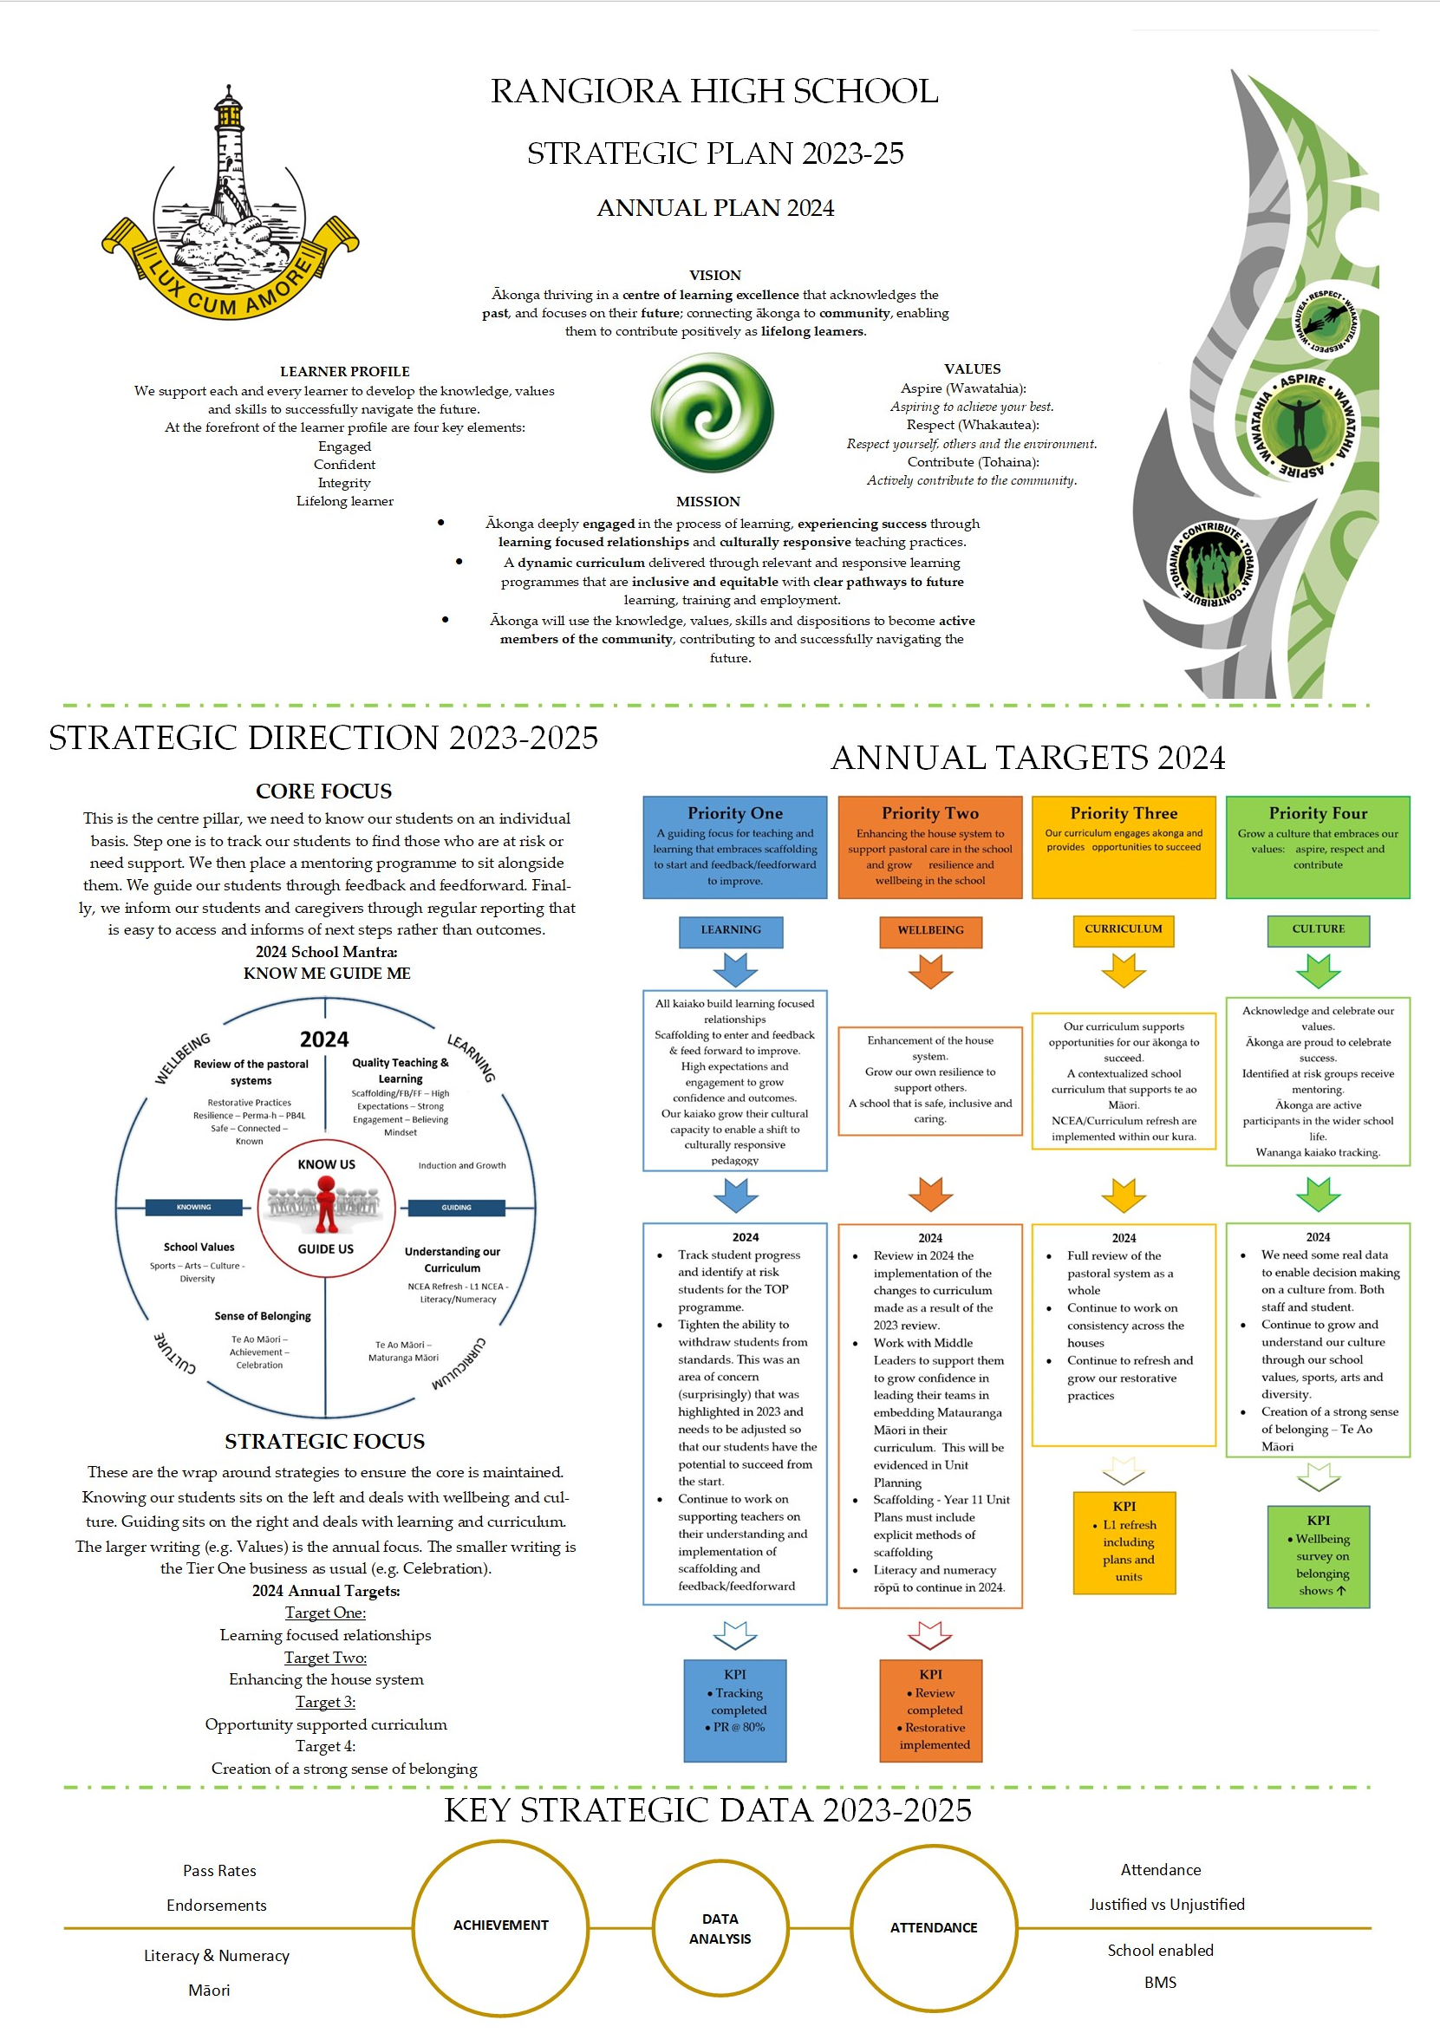
PART SEVEN:
APPENDIX

    - Report on annual target progression

- Learning
2023 Term One: Set up
- Our review of teaching and learning facilitated by impactED
- Know me data (class profiles) shared with staff
- Literacy and Numeracy rōpū established (first hui with team on Feb 27)
- PAT underway (Week 4-6)
- PLD with Rangiora High Staff on Scaffolding, Feedforward and Feedback on February 20
- Culturally Responsive survey underway (led by a WSL)
- WSL leaders were established to support Literacy/Numeracy/Culturally Responsive Practice
- First Literacy and Numeracy hui occurred on 27 February, very positive outcomes. Both rōpū have activated staff PLD through faculties and staff hui on March 27. These teams were led by both a Within School and a Literacy or Numeracy Co-ordinator
- PAT data was collected and shared with staff
- Know Me PLD with staff to access baseline data for classes occurred in Week 5
- PLD has occurred with staff on Feedforward, Feedback and Scaffolding - the impactED team used this to gather staff voice (the baseline for the confidence survey). The results of the recent review also highlight this is an area for strengthening in our kura
- Kōrero occurred with HTK our Mātauranga Māori and Mana Orite PLD provider on widening the scope of their current work to include all learning areas in 2023 (this is to support the results of the recent confidence survey with our kaiako)

2023 Term Two – Four: Implementation
Feedback/Feedforward and Scaffolding
- PLD was presented by impactED with Leaders of Learning on 8 May and 22 May. The focus on this PLD was Feedback, Feedforward and Assessment for Learning - this was then driven into faculties by Leaders of Learning
- A follow up planning meeting with impactED occurred on August 1.
- GROWTH model was explored with a team of invited staff who will lead this mahi. This team met with impactED on November 3
- The survey on confidence of our kaiako was shared with staff during Term 3.
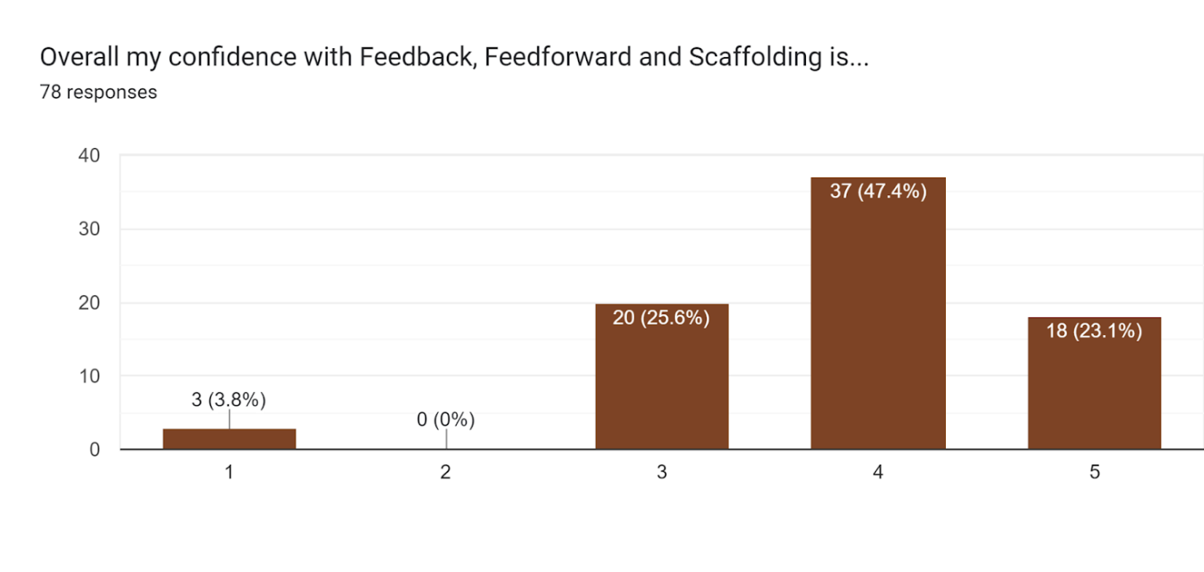
- We were successful in attaining 75 hours of RAPLD for the next year.

Mātauranga Māori and Culturally Responsive Pedagogy
- 32 staff attended PLD with HTK in the Week of May 1-5 to support and grow confidence in Mātauranga Māori
- A PLD application was submitted for May 12 PLD submission round with a focus on extending Mātauranga Māori support with our middle leaders. We were unfortunately unsuccessful for securing this due to submitting 2 PLD applications from our school. Our other PLD contract was successful.
- Term 2, Week 2 was our successful teacher only day with Kaiapoi High School. We managed to have a NCEA Implementation facilitator or Learning Area Lead from the Ministry of Education supporting all learning areas, either face to face or online. PLD also focused on the Cultural Capabilities and the link to Mātauranga Māori in learning areas. This day was effectively a self-designed ‘mini conference’.
- Our 9th iteration of Rongohia Te Hau occurred in Term 3 seeing over 40 staff observed across a 3-week period. The Kia Eke Panuku Team are our lead PLD around the Culturally Responsive Continuum that happened with staff in the Week 9.
- A successful Matariki celebration was organised by KEP team and held on the 19 July.
- We built PLD that was centred around Mātauranga Māori into the feedback session on the Rongohia Te Hau.
- A summary of the recent Rongohia Te Hau data was informative and of note:
  - 64% of staff observed were deemed to be at integrating (this is an increase from 61% in 2022)
  - Below is a summary of the 2023 survey results. While relational items are consistent with student and whānau voice, there is disparity between teacher perceptions and students and whānau around pedagogy.
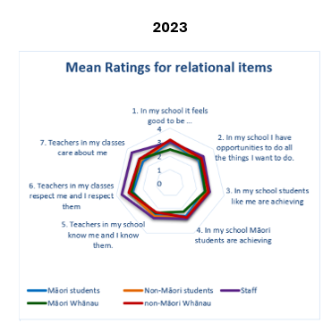
Other than care and respect (which of course is an issue) the results overlap and are relatively consistent between all groups interviewed.
The question that comes out of this is:
Whilst we clearly believe that we are and respect our students, they do not seem to agree. How can we show this care and respect so that student and whanau beliefs align with our own?
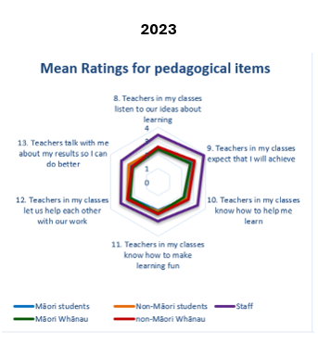
The most obvious feature here is that teachers’ thoughts do not align at all with whanau and students. Especially around expectations and knowing how our students learn.
The question that comes out of this is:
With both expectations and know me guide me at the forefront of our strategies, why do we not see a closer belief?

Literacy and Numeracy
- Tracking - led by the Tracking team allowed ‘credit predictions’ to indicate the Year 11 students who needed additional support towards the end of 2023
- An NCEA assembly was held with Year 10 in Term 2 Week 6 - to ready them for the Literacy and Numeracy exams in June. These exams occurred in Week 8 and showed clear correlation between success being able to be attained for those students at high Stanine 5 and in fact Stanine 6. It is concerning that our PAT results for Year 9 show 21% of students arrive at Rangiora High School at Stanine 1-3. It is therefore going to be a challenge to get some of these students to Stanine 5 or 6 by the end of Year 10 and 11.
- During the Term 4 Week 4, 264 Year 10 students sat the second Literacy and Numeracy examination. This was a shambles due to NZQA not being able to secure a strong platform. It was a very poor outcomes for our students and NZQA needs to be held accountable.

High Expectations:
- The kōrero around High Expectations has seen a kāhui wide focus with Nina Hood presenting to Rangiora High School staff and the whole Kāhui on May 31.
- During Term 2 Week 8, a meeting with the Specialist Classroom Teacher was held to begin kōrero on the development and trial of 3-minute walkthroughs. This was then extended to include the Learning Support Co-ordinator and the ‘instructional rounds’ model was built to be trialled in Term 4, for implementation in 2024. After a hui with impactED we believe this could link with the Feedforward, Feedback, and Scaffolding PLD, GROWTH mahi team. This will be further explored in 2024.
- Development of ‘The Opportunities Programme’ (TOP). 30 Year 11 students were identified ‘at risk’ and were given the option of a tranche of core generic unit standards, to support their learning and lift their achievement. This was such a success that we repeated it in Term 4.
Rangiora High School Curriculum Review
- Term 2 Week 5 saw the culmination in the Curriculum review which is now in the implementation stage for 2024

PLD Wider Staff
- Due to industrial action and the need for kaiako to be in classes with their students, a decision was made to cancel outside PLD in Week 7, for the remainder of Term 2. This was reversed once the outcomes of industrial actions came to light.
- PLD wider staff - there have been 113 PLD applications by individuals and groups of staff approved in 2023. This has seen staff attend numerous PLD, Conferences and hui to upskill their own personal identified learning needs. Much of this has centred around the implementation of Mātauranga Māori.

- Curriculum
Term One: Set up
- Review of teaching and learning facilitated by impactED
- Literacy and Numeracy rōpū established (first hui with team on February 27)
- PAT (Week 4-6) and data was collected and shared with staff
- WSL leaders were established to support Literacy/Numeracy/Culturally Responsive Practice
- Mātauranga Māori and Mana orite survey underway (led by a WSL)
- New reporting system launched in Week 4 and the feedback was positive - the emphasis to Learning Areas on publishing what is available for seniors in NCEA was implemented
- Both Literacy and Numeracy co-requisites scheduled for piloting with Year 10 cohort in June and December

Term Two – Four: Implementation
Rangiora High School Curriculum Review
- Term 2 focused on the sharing of the results from the review including LoL’s, then teachers and staff. The interest was incredibly high and the reflection and implementation team had to be split into two. The two groups created a number of recommendations that were discussed and bought to the wider staff. A smaller group was then created to push forward the collective view
- During Term 2 our course selection process was completed with Leaders of Learning (LoL) finalising courses for 2024 for uploading onto school point
- There was a Māori kaiako and students hui to input into how we communicate our changes to our community on June 14
- The changes from the impactED hui and process were communicated to our students in Term 2
- The implementation phase began in Term 3 and was fully in place for subject selection
- The outcome was:
  - New school timetable
  - Removal of semesters in the senior school
  - A change in junior semester and subject choices
  - Reduction in Wānanga
  - Return to six subjects at Year 11 and 12

Literacy and Numeracy
- Tracking was implemented to be a critical element
- An NCEA assembly held was with Year 10 in Week 6 of Term 2 to ready them for the Literacy and Numeracy exams which occurred in Week 8 of that term
- The results from the first round of L/N were:
  - Literacy: 148 students were eligible to sit this component, with 71% pass rate in Reading and 49% pass rate in Writing
  - Numeracy: 185 students were eligible to sit with a 74% pass rate.

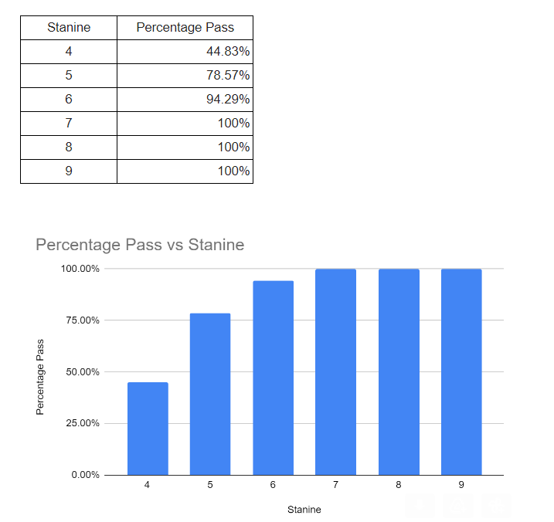
- The June Lit/Num show a clear correlation between success being able to be attained for those students at high Stanine 5 and in fact Stanine 6. It is concerning that our PAT results for Year 9 show 21% of students arrive at Rangiora High School at Stanine 1-3. It is therefore going to be a challenge to get some of these students to Stanine 5 or 6 by the end of Year 10 and 11
- 264 Year 10 students sat the second Literacy and Numeracy examination
NCEA/Curriculum refresh
- Evenings to speak about the NCEA changes and how NCEA works:
  - NCEA info evening for our Pasifika whānau and students
  - NCEA info evening for our Māori whānau
  - NCEA info evening for families where over 200 parents attended
- Meeting with MoE advisers Averill Manning and Megan Martin on May 26 regarding Te Mataiaho implementation and what the ‘need’ is in our kura. This was followed with a meeting between Megan and the Leaders of Learning in August
- A commitment towards implementation of Level 1 NCEA has seen faculties construct 15-20 credit courses for 2024. Many staff are accessing PLD on both new NCEA and Curriculum refresh offered by their subject associations
  - Faculties are continuing to prepare for Level 1 NCEA to be implemented in 2024
  - Curriculum refresh/NCEA staff progress survey was completed where our teachers have rated themselves/our school on how we are going in these areas. We will use this to structure PLD and extra support to areas of need for 2024
  - Curriculum Refresh/NCEA Implementation Tool
  - TOD on 20 November was faculty based preparing for 2024 and the NCEA/Curriculum changes
Our curriculum supports opportunities for our ākonga to succeed.
- All Year 12 students completed an all-day RYDA Road safety Driving course. They then complete a 3 credit Unit Standard aligned to the course
- All Leaders of Learning (LoL) presented to SLT their faculty’s 2022 Level 1 academic results. They presented what went well and what needs strengthening
- Faculties have designed new programmes of learning based on the new curriculum structure

Tracking
- Tracking created with ‘credit predictions’ to indicate the Year 11 students who needed additional support towards the end of the year to support student outcomes to increase
- Students were identified to be involved in ‘The Opportunities Programme' (a 10-credit course). This was offered to identified ‘at risk’ students with parental permission to complete this course in Week 10 of Term 2. This saw 36 students participate and the first group of 18 students were able to achieve 10 credits in the time provided. The second group in the final two days of Term 2, needed additional support that we could not provide. ‘At risk’ students identified through tracking in Term 4 were given the opportunity to complete ‘The Opportunity Programme’ when the seniors were on study leave. There were 36 students. At the end of the programme 72 students had completed this programme in 2023.
- Based on the tracking data extrapolated from round 2, teacher estimates indicated 76% of students will attain Level 1. Our actual pass rate was 69.2% leaving us -6.8%

Mātauranga Māori Confidence Survey
- In Term 4, a confidence survey of our staff showed that a vast majority were at a confidence level of 60% or more. There is room for improvement in 2024, this will be supported by our RAPLD contract with HTK.
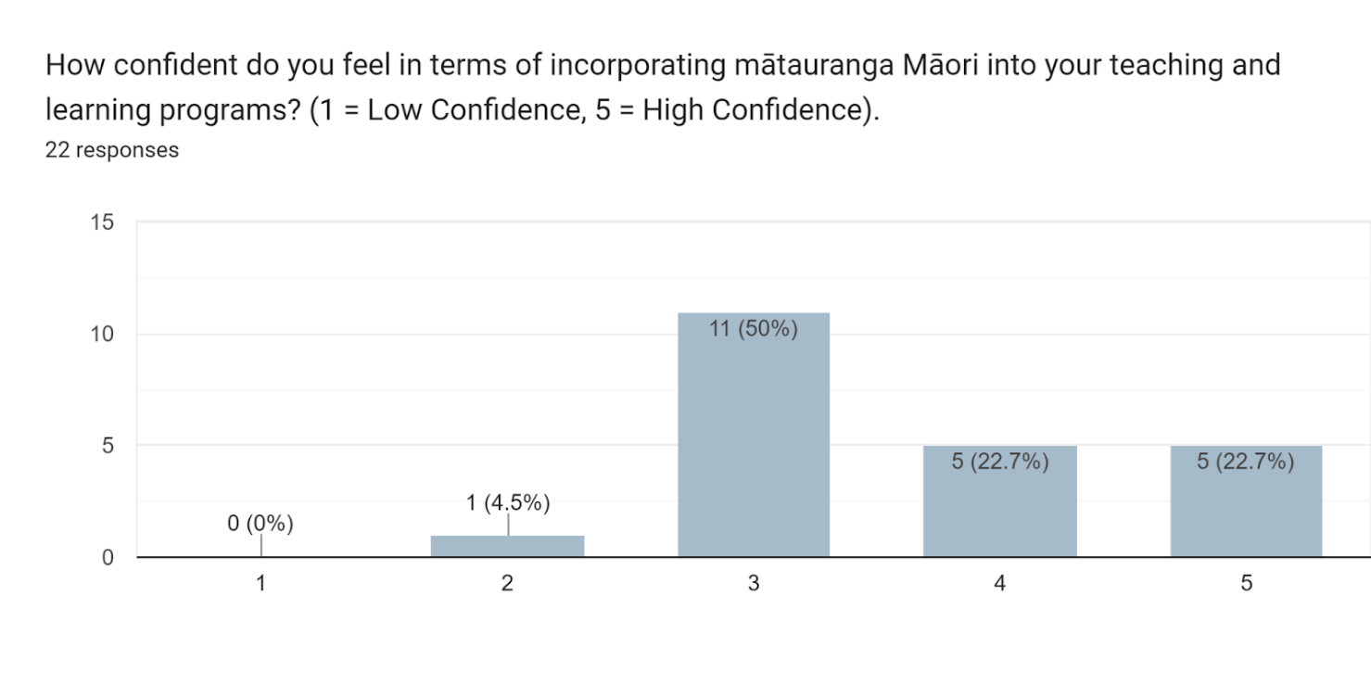
- Wellbeing

Term One: Set up
- A key starting point was identifying actions for 2023. There was (and still is) a need to improve consistency of pastoral responses across the various levels - from the classroom to the House to the SLT. A possible model was presented to the Pastoral Network for discussion, and during the term the collected data will inform any change. It was WONDERFUL to see students at Sports Day, and full school assemblies after such a long break due to Covid etc.
- The staff PERMAH survey ran again mid-term 1, with the student version of it towards the end of Term 1. Three staff built this survey based on the PERMAH framework.
- Three staff attended the Margaret Thorsbourne Restorative Practice training in March - two of the staff were newly appointed Within School Leads who will be key to re-newing staff skills in this area, and also consistency across Houses.
- We are researching anti-bullying programmes for schools. While there are some existing ones, ERO suggest that the most effective anti-bullying approach is for a school to pick relevant (to them) aspects from a range of sources, and build this into their own programme. This work will continue through Term 1.

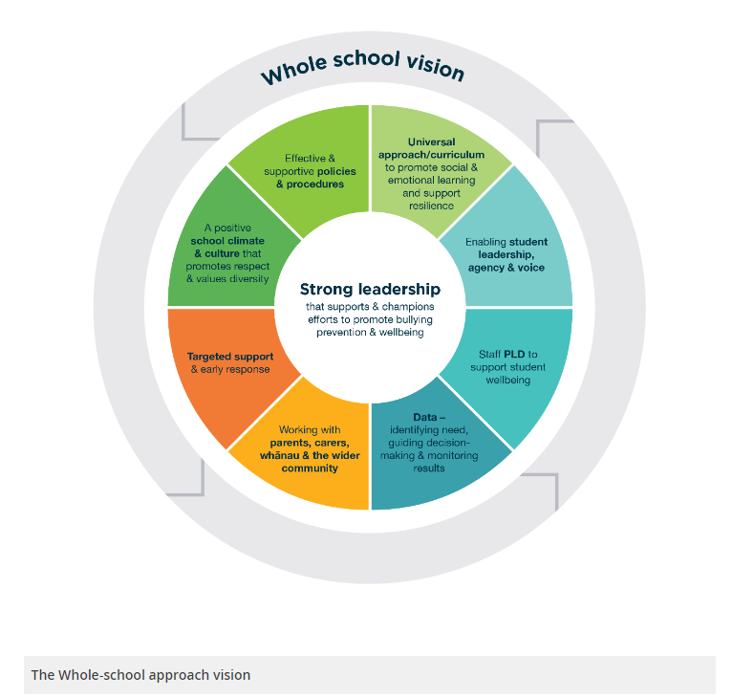

Clear anti-bullying programme.
- A key focus for this portfolio was ensuring our school has a clear anti-bullying programme. A important document for me this year was the ERO report into bullying responses and prevention in New Zealand schools. It is particularly relevant as many “off the shelf” anti-bullying programmes are focused at Primary School level. The report also observes that the most effective schools in bullying prevention and response have adopted a general school wide approach, and then cherry-pick the specific opportunities that occur.
  - The most effective schools were distinguished by the commitment of their leadership, the consistency of their approach, and robust internal evaluation and monitoring. Schools with sound internal evaluation practice drew on a range of evidence to make sure they had a good sense of patterns of bullying incidents, and how well their prevention and response strategies were impacting on student safety and wellbeing. They used this information to continually improve their practice, targeting areas that most needed attention.
  - Effective leaders were also discerning in their use of specific bullying prevention programmes, employing these when evidence suggested they would support the school’s overall approach, or address issues of immediate concern.
  - ERO recommends school leaders use the Bullying Free NZ Framework and associated resources to:
  - Make sure school staff and community have a shared understanding of what constitutes bullying behaviour, school policies are up to date, and bullying prevention and response processes are consistently evident in practice
  - Strengthen data collection, analysis and evaluation of bullying prevention strategies, including the impact and effectiveness of any specific programmes implemented
  - Provide opportunities for students to have input into the development of bullying prevention and response strategies, and empower student-led initiatives and groups
  - Involve parents and whānau more proactively in bullying prevention in addition to response.

- Stocktake at RHS:
  - In terms of a school-wide approach, we have embedded PB4L into our school since 2013. We are at the point where we can shift to Tier 2 of this if we choose to. PB4L data does not show Bullying or Harassment as significant problem areas, however the individual incidents can become significant ones. We have also used Restorative Practice as a key template for how we have robust conversations in a mana enhancing way.
  - We are working on improving consistency in both of these areas. The updated (Draft) Major Procedures document has some changes in process that are documented on the first page- there have also been some simplification of responses for each section. The aim here is to improve consistency of action/response at every level. To assist with this the Pastoral Flow Chart clarifies measures that need to be utilised as student behaviour or attendance becomes an issue- some of these are classroom based expectations and strategies.
  - Our two Within School leads (Richard Winson and Jasmine Lines) have just finished attending a three-day Restorative Practice course. They are charged with ensuring RP process is followed correctly, and that we do not run into a circular RP response for incidents, be it a restorative chat or a full-scale conference.
  - We also address bullying in an educational way through Health classes at Year 9 and 10, and as part of the Wānanga curriculum. Sometimes this is specific to an event (Pink Shirt Day), and sometimes more holistically linked to a Disposition, such as Resilience. There are also specific Cyber-safety units of work for Year 9 and 10.
  - The PERMAH survey will run in Week 2 of Term 2. We are hoping to have completed the student version of this for delivery soon after. This focus on Wellbeing strategies and awareness is important to bullying prevention. We have also invested in additional Guidance Counsellors for specific support.
  - We “buy into” other supports as they come along. The Attitude speaker in Week 5 who spoke to every year level at RHS is a good example of this, as is the talk by Israel Dagg and Jazz Thornton organized by our Heads of Sport, delivered to members of sports teams. This is exactly the targeted approach as suggested by ERO.
  - One area of potential is around Peer Mentoring- with a focus on Pastoral support. There is an academic mentoring programme underway at RHS, and it may be that this model is utilised for a student led pastoral mentoring programme. There is some hesitation with this- it was trialled a number of years ago at RHS and there were some fundamental learnings from this.

Term Two – Four: Implementation
Wellbeing

- The staff PERMAH wellbeing survey was completed by 72 staff during the first week of May. There were some really pleasing, key improvements:
  - Staff who describe themselves as Consistently Thriving increased from 7.2% in 2022 to 20.8% in 2023
  - Staff who describe them as really struggling dropped from 17.4% in 2022 to 5.6% in 2023
  - There were also increases across the school in all the PERMAH pillars, with the biggest increase in Accomplishment (from 58 in 2022 to 73 in 2023
- This is really good news, and it is important to note that this can be contributed to a range of factors, from the specific Wellbeing PLD that has been delivered to staff over the last two years, to the change in leadership approach that the school currently has.
- The student version of the survey has also been completed, although we do not have any comparative data for this. The survey does show a large group ‘just getting by’ (40%) and the PERMAH pillars of Engagement and Meaning are the key areas to focus our efforts on. In teenage speak, we need to address “This is boring” and “What’s the point”
- Tony Jones, Head of Guidance presented the bones of a guidance/wellbeing model to staff. This model incorporated the role that Elise Bramley took following her appointment, as well as the idea of a few initiatives such as Stymie. Stymie is a platform that provides the ability for students to make anonymous disclosures or to note concerns of any type, that are then responded to. Following discussion with Pastoral Teams, and meetings with the Stymie team, we decided to roll this out for the start of Term 4. There was a whole staff session on Monday, and Tuesday saw presentations to each year group during the day. The response was very successful. There were immediate “submissions” by students, mostly self-disclosures. Two of these were significant in nature and from students who were not known to Guidance. There continues to be a steady trickle of responses, with only 1 response that is clearly “taking the mickey”. It shapes up to be a key tool in dealing with a range of issues, particularly those who are being bullied or are feeling excluded.

House and Pastoral
- There was a clear reframing of pastoral processes, to ensure that students are treated consistently and effectively. There has been an improvement in this area, and yes this has resulted in increased stand downs and suspensions as some of these processes are tested.
Houses will all be using a common spreadsheet for recording and tracking pastoral and attendance concerns by the end of Term 2.
- The appointment of Su Jeffcott as Truancy officer is a positive decision. She was focussed initially on students whose attendance rate is between 70% and 85% as we felt we would make the quickest impact in this area.
- Elise Brambley was appointed to the Guidance Department and this has helped bring the amazing support that occurs on an individual level, to a greater number of students and school wide. This is a 2-3 year plan as she is studying at the same time.
- House events continued, although it was increasingly difficult to find time and space for these to occur due to industrial action and business. The Heads of House are very keen for events to continue as part of reviving the House competition and general spirit.
- Richard Winson and Jasmine Lines (Within school leads with a focus on restorative practice) have started to look at some processes to ensure that the restorative aspects are embedded with fidelity in 2024. They started with the detention process, and the referral process.

Bridge
A brief summary:

Bridge is the school funded programme that places students at risk in a short-term placement with the purpose to bridge them back into mainstream schooling. It allows us to reduce the impact on alternative education and suspensions.

- Currently, 58 students have taken part in Bridge in 2023
- At the end of Term 3, 2023, there had been 34 students taking part in Junior Bridge
- There have been 24 students taking part in Year 11 Bridge
- All 6 houses have referred students to the Bridge Programme
  - Hillary = 6
  - Sheppard = 11
  - Ngata = 8
  - Mansfield = 8
  - Lydiard = 8
  - Rutherford = 5
- 68% of the students were NZ European
- 30% of the students who participated in Bridge in 2023 were Māori
- 2% were Vietnamese
Bridge 11:
- 54% of Student had achieved Numeracy AND Literacy
- 31% of students had Achieved Numeracy OR Literacy
- 15% of students had achieved neither
- 54% had improved Behaviour over the course of the year
- 54% had better attendance in Bridge than overall
- 23% did not have improved behaviour or attendance in Bridge

Junior Bridge:
- 66% of student had better attendance in Bridge than overall
- 63% of students had improved behaviour over the course of the year
- 41% had BOTH improved behaviour and better attendance in Bridge

- Culture

Acknowledges and celebrates our values
- The acknowledgement and celebration had a three-prong core approach:
  - Assemblies – these were inconsistent and the following recommendations are in place:
    - SLT take turns to drive the values session (in place and working well)
    - Cohesion between the house and SLT assemblies on the values that term/fortnight
    - Greater voice from students
  - PB4L – the energy placed into this was fantastic from the team and numbers of recognition was good. The shop was especially worthwhile for the students. The next step is creating a strategy to widen the number of staff who use this recognition system.
  - Five seconds of bravery – two head students used this as their portfolio. Encouraging people to stand up and support the victim of harassment and bullying was outstanding and this needs to be grown again in 2024

Ākonga are proud to celebrate success
- Build a collection of recent graduates – stories of students – success narrative – Story/Honors board (visibility) – there was success with the honours boards but the stories need to be reviewed and potentially grown
- Academic Awards Ceremony – this was an absolute success and needs to be continued into the future. Māori and Pacifica staff requested to create a ceremony that acknowledge their achievement – this needs to be unpacked in 2024
- An academic committee of students was developed. (they wanted more of a say in what academic work is promoted)

Ākonga are active participants in the wider life of the school
- Performing Arts: collecting data on student participation – we used the Canterbury data and results were on the rise. Staff participation was decreasing for the same period – an area to unpack.
- Performing Arts: The Show Quest evening was a sellout; the evening was an opportunity for us to show our whanau the talent of our student and staff. A very enjoyable night
- Performing Arts: Compass Radio interview: Bex McLean, Marlene Vorster (student) Arts Captain.
- Directors Sport: Developed a players and coaches code and will be mandatory in 2024. Sport administrators/coordinators have created management model to administer all codes. Sport uniforms have been designed/developed to create unity and identity across all codes.
- Year 9 Camp: Review and Report completed and the camp will go ahead in 2024 as directed by the Board.
- Colours Prizegiving (sport and performing arts)
- The number of recipients gaining awards this year is the largest we have seen since 2014. Thirty-four recipients - for culture/performing arts, the recognitions are three times as many last year.

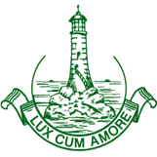
- EEO Policy

Rangiora High School
Te Kura Tuarua o Rangiora

Equal Employment Opportunities Policy

Rationale
The Rangiora High School Board is committed to the principles of equity and inclusion. Consistent with these principles, the Board has made a commitment to an Equal Employment Policy which promotes equality of opportunity for staff regardless of age, disability, gender, marital status, race, ethnicity, religious belief, political opinion, employment status, family status or sexual orientation.

Purpose
The purpose of this policy is to recognise the need to give practical effect to these responsibilities both as an employer and as an educational provider:
- To ensure that all school policies and procedures incorporate EEO requirements
- To provide a non-discriminatory, culturally sensitive and safe working environment for all staff
- Ensure that all employees and job applicants are treated according to their skills, qualifications, abilities and aptitudes
- To encourage a diverse makeup of staff to reflect the school student community and provide a range of positive role models
- In order to ensure equity of access, RHS will ensure that
  - Promotion is made on the basis of merit and
  - All staff have equal access and encouragement through professional development and learning opportunities to perform to their maximum potential

Scope
This policy applies to all staff, job applicants and volunteers at Rangiora High School.

Guidelines
- The programmes based on this policy will reflect both the content and the spirit of the school’s Strategic and Annual Plan
- To commit to meeting responsibilities under Te Tiriti o Waitangi, the EEO Programme will contain objectives which show that we accept the principle of partnership
- RHS EEO Coordinator is the Deputy Principal (Framework) and has responsibility for:
  - Maintaining the database to identify members of the EEO target groups and an employment profile of the school
  - Working with the School Board, Principal and staff to
    - Establish specific EEO objectives which identify the employment requirements of Māori, Pacific Islands people and other ethnic groups, women and people with disabilities
    - Positive action strategies will be implemented where these are identified as being appropriate to address the needs of EEO target groups
    - Reviewing practice, procedures and policies to incorporate requirements and the EEO objectives. Particularly in the areas of:
      - Recruitment and selection
      - Promotion and career development
      - Professional development and learning
  - Systems used to monitor the School Board’s Equal Employment Opportunities Plan
  - Meeting regularly with EEO "target group" networks and being available to staff for advice
  - Coordinating the development and implementation of the annual EEO programme
  - Reporting the programme to the School Board. This report must include reference to:
    - The EEO plan, identifying the EEO Objectives set for the previous year. (Each objective contains a performance measure that will help assess achievement in meeting the objective).
    - Major achievements
    - Implementation difficulties (i.e. identify EEO objectives that have not been achieved, commenting on any barriers that may have hindered achievement).
    - Conclusions i.e. comment on any other EEO areas that need to be addressed in relation to:
      - Recruitment and selection
      - Promotion and career development
      - Professional development and learning
      - Working conditions
- All staff members are responsible for reporting any discriminatory practices, work environment or conditions of employment that are inconsistent with EEO policy principles to the EEO Coordinator or the Principal
- In making appointments the person best suited to the position shall be appointed. The School Board shall have regard for the experience, qualifications, training, skills and abilities of the applicant and the needs of the school and any other requirements of the position as specified in the job description and person specification for that job.

Related Policies
Complaints Policy Personnel Policy
Te Tiriti o Waitangi Policy

Related Legislation
Equal Pay Act 1972
Human Rights Act 1993
New Zealand Bill of Rights 1990
Public Service Act 2020

Date of Review | June 2023
Date of Next Review | June 2026
Date Adopted by Board | August 2023
Date of Amendments by the Board

